# Introduction

## Zoonotic infectious diseases

Zoonotic infectious diseases – or “zoonoses” – in humans are caused by pathogens transmitted either directly (e.g., bites or scratches) or indirectly (e.g., via vectors, environmental or food contamination) from animal hosts,including livestock, wildlife, and pets (World Health Organization, Food and Agriculture Organization of the United Nations, and World Organisation for Animal Health 2019). Zoonoses include bacterial, fungal, parasitic and viral microorganisms. However, zoonotic pathogens do not always cause clinical disease in their animal hosts. For example, *Lassa mammarenavirus* (LASV), the causative agent of Lassa fever in humans, is not considered to cause significant clinical disease in rodent host species as measured through organ dysfunction, weight loss or behavioural change (Safronetz et al. 2022). However, in humans, LASV infection can lead to severe clinical symptoms and death (Thielebein et al. 2022). In contrast, Highly Pathogenic Avian Influenza, caused by *Influenza A virus* (subtype H5N1), leads to significant morbidity and mortality in infected bird species alongside pathogenicity in humans (Haider et al. 2017; Writing Committee of the Second World Health Organization Consultation on Clinical Aspects of Human Infection with Avian Influenza A (H5N1) Virus 2008).

The wider term “zoonotic disease” is often used for diseases that first originated in non-human animals but where subsequent disease transmission is no longer dependent on an animal reservoir (e.g., HIV, SARS-CoV-2) (Kock and Caceres-Escobar 2022). Individual transmission events from vertebrate animal populations into human populations - “spillover events” - can lead to sustained outbreaks that may progress to localised epidemics or global pandemics (Plowright et al. 2017). However, patterns of spillover differ across zoonoses. For example, Nipah virus infection (*Nipah henipavirus*) and LASV spillover events from wild animal sources occur at relatively frequent intervals but result in limited, onward human-to-human transmission. This further leads to small-sized, geographically constrained outbreaks of human disease (Luby et al. 2009; Lo Iacono et al. 2015). In contrast, Ebola virus disease (*Sudan ebolavirus* and *Zaire ebolavirus*) and mpox (formerly Monkeypox caused by the *Mpox virus*)exhibit sustained human-to-human transmission following spillover, but due to the transmission dynamics of these pathogens, outbreaks are generally constrained to local epidemics (Legrand et al. 2007; Fine et al. 1988). In addition, some pathogens may be better adapted to transmission among humans due to their specific properties or similarities between human physiology or immunology and those of the primary vertebrate reservoir. Such pathogens are able to rapidly expand beyond the geographic region of the initial spillover event via human transmission chains and may become zoonotic diseases with no further important transmission from wild or domestic animal populations (e.g., HIV and SARS-CoV-2) (Ye et al. 2020; Marx, Apetrei, and Drucker 2004). Spillover may not be limited to a single direction of animal to human transmission and “spillback” can potentially play important roles in maintaining pathogen endemicity with subsequent “secondary spillover” into human populations, and alternatively, spillback can lead to morbidity and mortality in animal populations (Fagre et al. 2022).

The different patterns of spillover are observable through phylogenetic analysis of viral sequences from human populations. For example, phylogenetic analysis of the SARS-CoV-2 virus suggests an initial spillover event into human populations in October and November of 2019, with establishment in the local human population ultimately leading to a global pandemic beginning in early 2020 (Pekar et al. 2021). Similarly, the multi-country mpox outbreak in 2022 is proposed to be secondary to human-to-human sustained transmission from a single origin endemic country, either directly linked to a spillover event or cryptic transmission among local human populations (Isidro et al. 2022). In contrast, phylogenetic analysis of LASV sequences indicate that the most common recent ancestor of viruses currently circulating in Nigeria originated >1000 years prior, while sequences from Guinea and Sierra Leone suggest a more recent introduction 220 and 150 years ago, respectively (Andersen et al. 2015). These findings are consistent with repeated spillover events into human populations from pathogens circulating within a single or multiple reservoir species. While the 2022 mpox outbreak and ongoing SARS-CoV-2 pandemic are important examples of zoonoses causing epidemics and pandemics beyond their host species’ ranges, these remain relatively rare events when compared to recurrent spillover events within endemic regions (Dudas et al. 2018; Lloyd-Smith et al. 2009). The example of LASV highlights the risk of recurrent local spillover into human populations in endemic regions and reinforces the importance of surveillance of known zoonoses.

When considering interventions to reduce the health impact of zoonoses in endemic settings (e.g., through reducing the risk of recurrent local spillover events), an approach that incorporates knowledge of multiple interacting systems are required. Understanding the role of environmental, wildlife and human factors on the risk of spillover events are necessary. This is often termed the “One Health” framework: a “collaborative, multisectoral, and transdisciplinary approach - working at the local, regional, national and global levels - with the goal of achieving optimal health outcomes recognizing the interconnection between people, animals, plants, and their shared environment.” (“One Health CDC” 2022). This framework is particularly useful when considering how spillover of zoonoses occur in a context of ongoing climate, land use and biodiversity change.

## Global climate change and zoonoses

Anthropogenic climate change has long been known to modify the risk of spillover of zoonoses to human populations through several mechanisms (Jones et al. 2013; Daszak, Cunningham, and Hyatt 2001). For example, changes in mean temperature and precipitation will alter environmental suitability for both pathogens and hosts leading to expansion or contraction of endemic regions (Mills, Gage, and Khan 2010). In addition, environmentally transmitted zoonoses, such as Leptospira, become better able to persist in the environment under changes that increase ambient temperature in the presence of increased precipitation, leading to higher prevalence and incidence of infection (Lau et al. 2010; Llop et al. 2022). Vector borne zoonoses such as West Nile Virus are currently demonstrating range expansion as both mosquito vector abundance and occurrence is increased across a larger geographic range, likely due to… (Farooq et al. 2022; Hoover and Barker 2016).

Climate change is occurring in step with anthropogenic land use change. Human driven conversion of natural landscapes towards human dominated use occurs at both a local and global scale through direct and indirect human actions (i.e., agricultural development, natural resource extraction, and urbanisation) (Gottdenker et al. 2014). The association of land use change and pathogen transmission is complex, with increasing, decreasing and no change in pathogen transmission reported from observational studies of pathogen systems (Gottdenker et al. 2014). Encroachment of human activity into zoonotic host animal ranges, as can occur under conditions of land use change, has been hypothesised to increase the risk of spillover events into human populations, through increasing the animal-human interface and raising the probability of direct and indirect contact with infected hosts of zoonoses (Murray and Daszak 2013). Additionally, heightened interactions between wildlife and domesticated animals as a consequence of land use change may also increase the risk of subsequent zoonosis spillover into human populations, where wild sylvatic animals are hosts of pathogens that can be amplified in domesticated animals (e.g., Nipah and Hendra virus) (Plowright et al. 2015; Epstein et al. 2006). In tandem, climate and land use change can also modify species’ home ranges. As a consequence, an increased frequency of contact events between current and potential future hosts of zoonoses are produced, increasing the potential for cross-species pathogen transmission and the subsequent expansion of a zoonosis’ endemic range (Carlson et al. 2022). This has been observed with regards to Hendra virus, where Southern range expansion of the black fruit bat (*Pteropus alecto*) has resulted in domesticated horses in Australia being infected, with subsequent spillover events into human populations (Yuen et al. 2021).

Animal biodiversity (or lack thereof) has also been proposed to modulate zoonosis spillover risk, with several mechanisms proposed. The “Dilution effect” - initially applied to the Lyme disease system (*Borrelia burgdorferi sensu lato*),which comprises several vectors and animal hosts - hypothesises that in settings of low species diversity (operationalised as species richness), infection rates increase in a host species. The inverse scenario is one in which higher levels of animal biodiversity is protective through reducing the rate of zoonosis spillover into human populations (Ostfeld and Keesing 2000). This theory has been supported by studies of several pathogen systems across parasites, bacteria, viruses and fungi (Keesing et al. 2010; Civitello et al. 2015). There is ongoing debate as to whether the Dilution effect is a general property of zoonosis systems, with several studies suggesting the inverse. This opposing mechanism, termed the “Amplification effect”, occurs when increasing biodiversity, particularly through introduction of a new or a more competent host species can increase the rate of infection in hosts and potentially the risk of zoonosis spillover (Johnson and Hoverman 2012; Halliday et al. 2017). These two effects may exist as a spectrum where dominance of one over the other is dependent on the specific disease context (Gómez-Hernández et al. 2023).

Climate, land use and biodiversity change are interacting components within an ecosystem and attributing an effect of each independently to the risk of zoonosis spillover is challenging (Gibb, Franklinos, et al. 2020). A synthesis of the effect of land use change on biodiversity across multiple spatial scales and zoonosis systems found that species richness of zoonotic pathogen host species, but not non-host species, increased along an anthropogenic land use gradient (Gibb, Redding, et al. 2020). It should also be noted that the observed land use changes are occurring at different rates globally, which may muddle current findings. Climate, land use and biodiversity change occurring in regions associated with a greater diversity of known zoonotic pathogens may potentially have a greater impact on the risk of zoonosis spillover than in settings of low diversity of zoonotic pathogens.

## Zoonoses discovery and species affinity: sampling considerations

The majority of microorganisms are non-pathogenic to humans or animals and provide vital ecosystem services. The small subset of microorganisms (<1%) that are pathogenic are typically able to replicate in multiple hosts (Editors 2011; Cleaveland, Laurenson, and Taylor 2001; Mark E. J. Woolhouse, Taylor, and Haydon 2001). It has been estimated that 60% of emerging human infectious diseases are associated with known zoonoses; therefore,it is not rare for a human infectious disease to be a zoonosis(Jones et al. 2008). The discovery of zoonoses is variable across mammalian taxa, with sampling efforts increased in orders with increased human interaction (i.e., primates and livestock species). Zoonoses are known to exist in the majority of terrestrial mammal orders (21/27) with the number of hosts of zoonotic pathogens strongly positively associated with the species richness of these orders (Han, Kramer, and Drake 2016). A recently compiled dataset (CLOVER) contains an increased number of documented pathogens in Primates, Artiodactyla (ungulates) and Carnivora alongside Rodentia and Chiroptera (Gibb, Albery, Becker, et al. 2021; Gibb, Carlson, and Farrell 2021). Figure 1.1 shows the number of known pathogens in these mammalian orders. Of these, Rodentia contain the greatest number of pathogens known to be zoonotic (Han, Kramer, and Drake 2016).

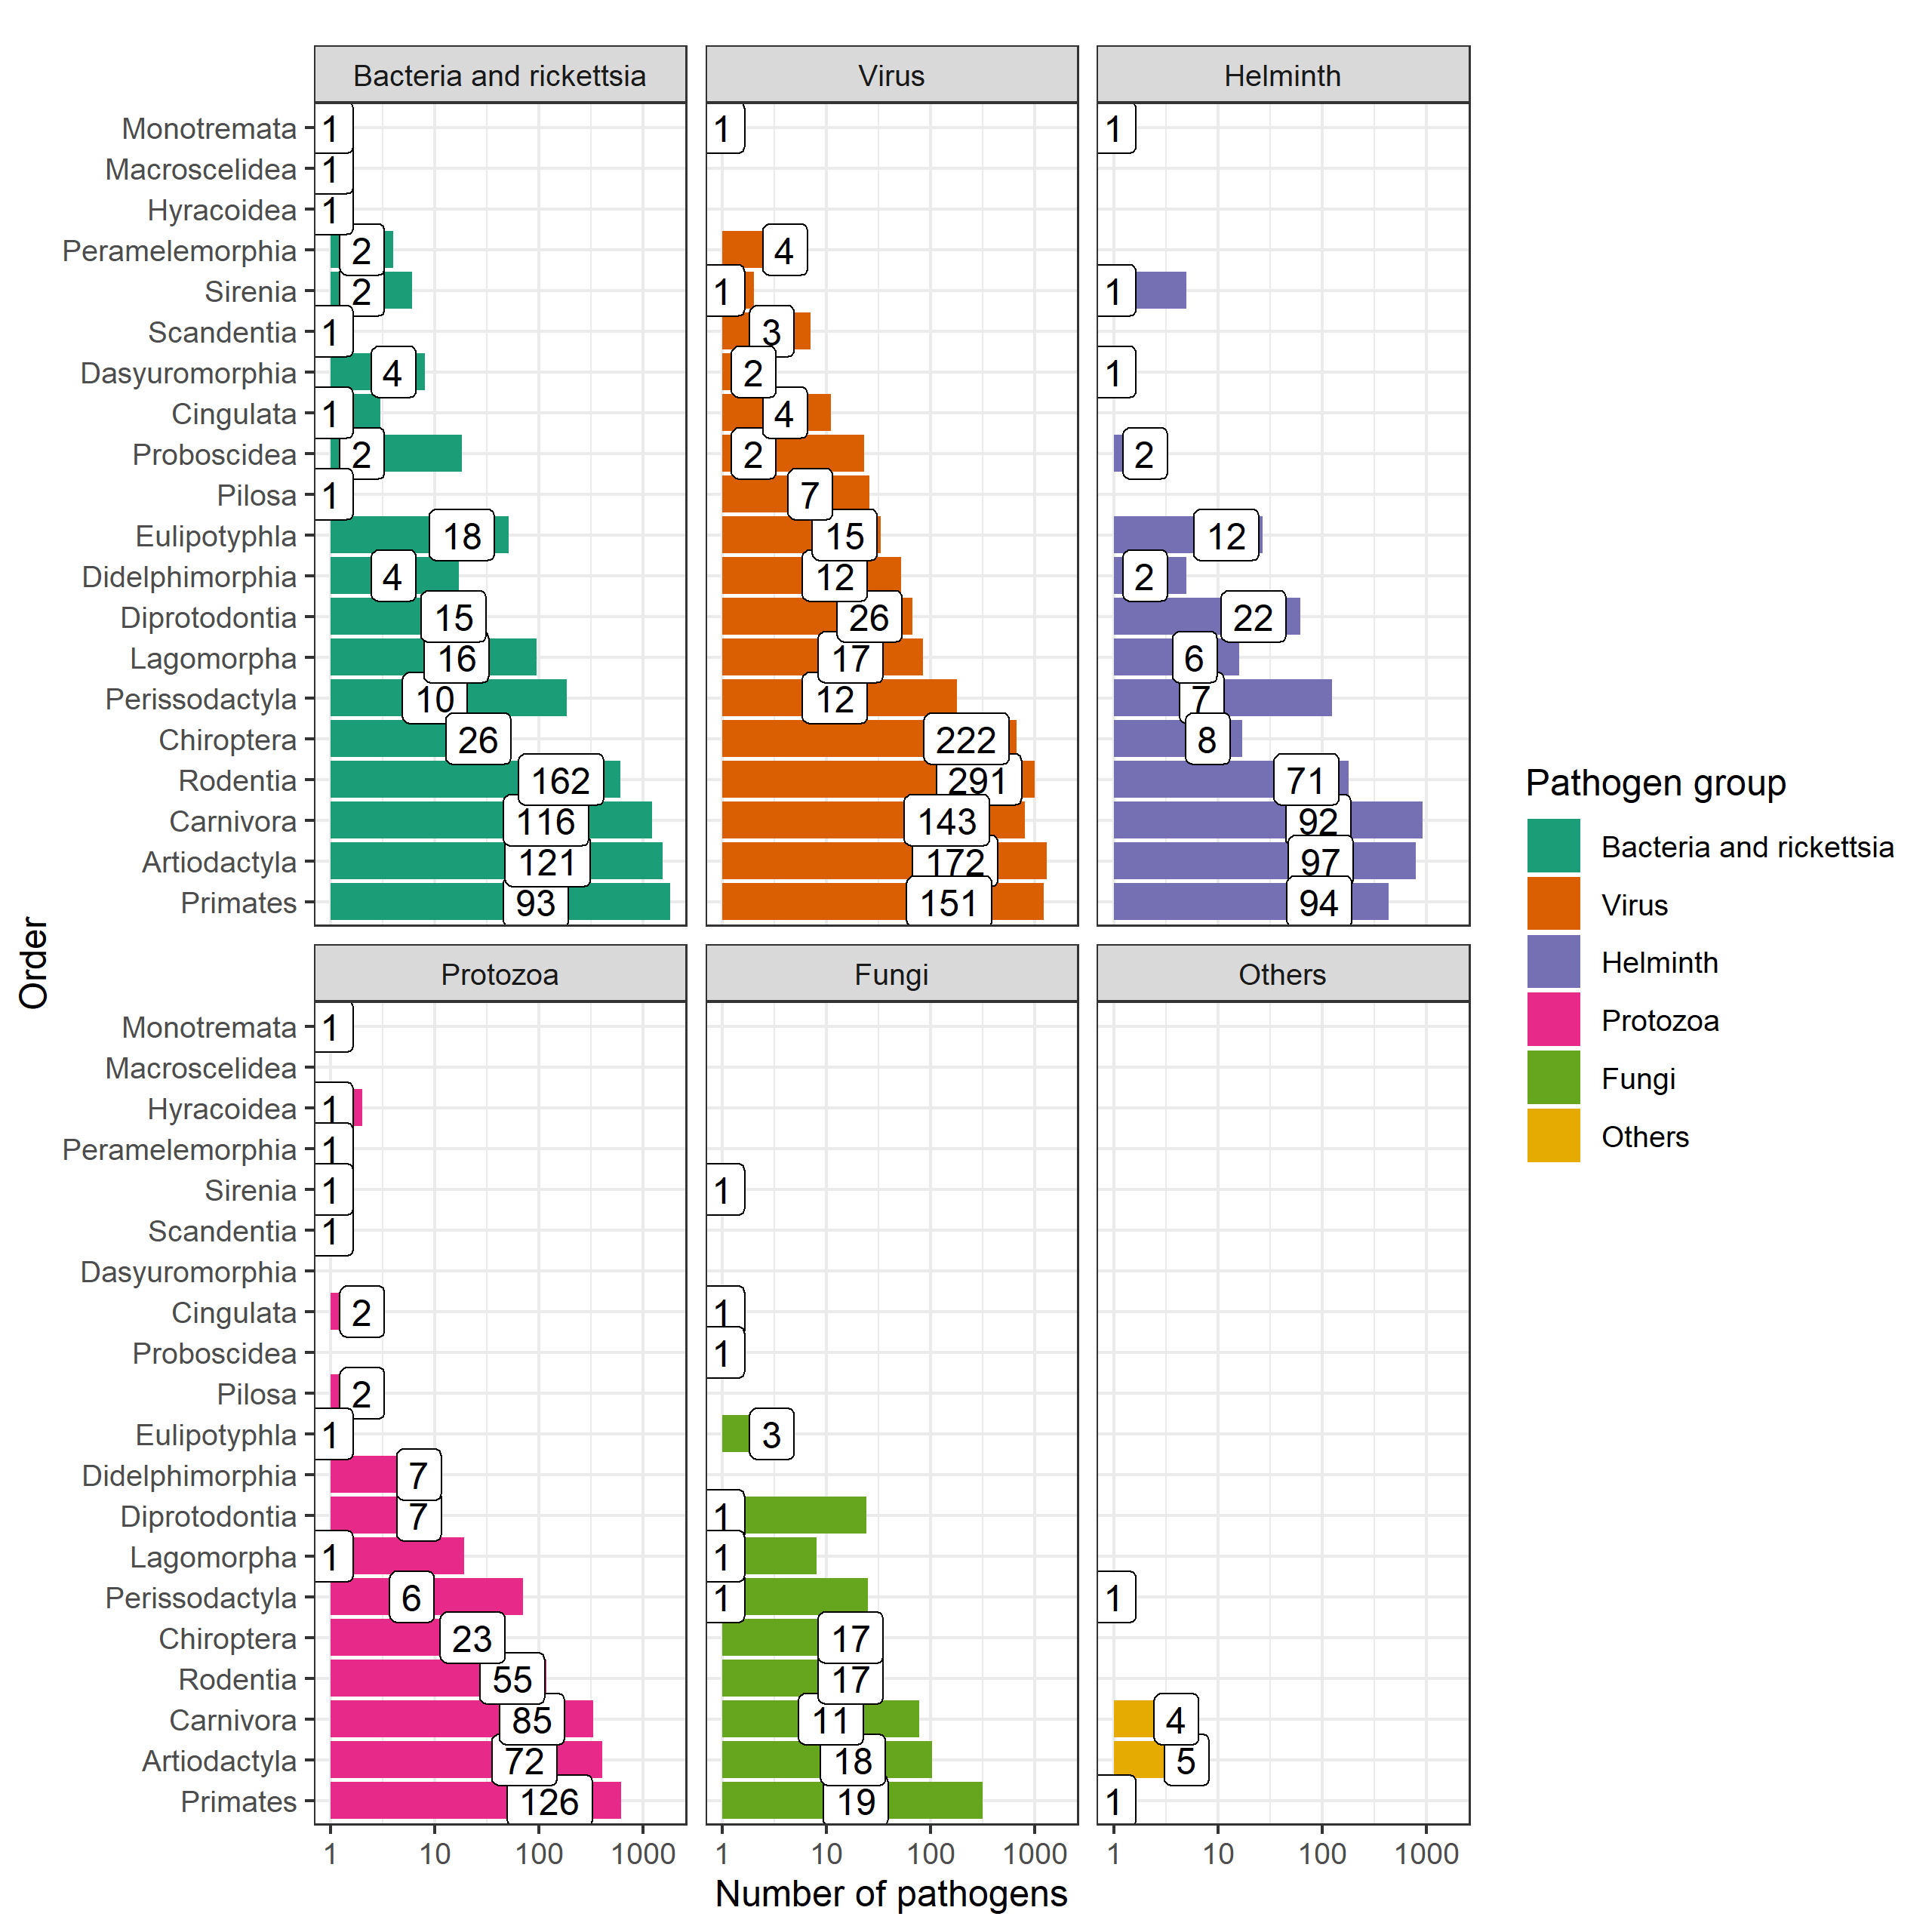

Figure 1.1 The sampling of the global host-pathogen system is incomplete and sparse. Bars indicate the number of known pathogens within different mammalian orders; the values within the bars indicate the number of species within the order known to host these pathogens. Data obtained from CLOVER (ref?).

As can be gleaned from Figure 1.1., two mammalian taxa, Rodentia and Chiroptera are associated with the greatest number of species that are hosts of zoonoses and overall number of zoonoses (Han et al. 2015). It is unclear whether these taxa represent special reservoirs that lead to an increased proportion of zoonotic viruses circulating within these species or make them more likely to transmit pathogens to humans, or whether the increased number of zoonoses associated with these taxa is driven by their increased species richness – in line with the “Amplification effect” hypothesis (Olival et al. 2012; Wolfe, Dunavan, and Diamond 2007; Luis et al. 2013; Mollentze and Streicker 2020).

These documented pathogens notwithstanding, the discovery of zoonoses is biased both by our ability to detect them and the sampling effort within different animal speciesand geographic regions (Grange et al. 2021; Gibb, Albery, Mollentze, et al. 2021). The discovery rate of viral zoonoses, an important subset of all zoonoses, has increased with improvements in the technical means to detect and identify them (Woolhouse et al. 2008). The rate of discovery has exceeded prior expectations of viral biodiversity, but continues to remain taxonomically and geographically biased, thus limiting the inferences that can be made with regards to, for example, the risk of spillover events drawing on current data sources (Wille, Geoghegan, and Holmes 2021). Similar limitations are likely for other zoonoses taxa, including bacteria, fungi and parasites. The general trend of increasing rates of pathogen discovery over time are shown for Rodentia in Figure 1.2.

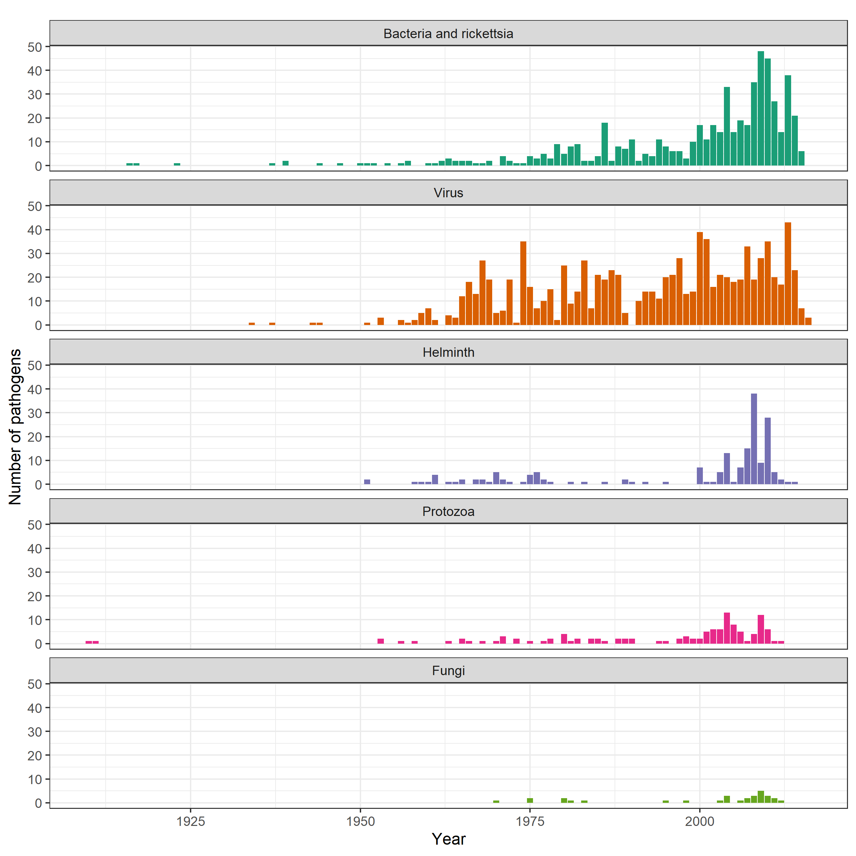

Figure 1.2 Discovery of pathogens in Rodentia, the order containing the greatest number of zoonotic pathogens, has increased over time. Data obtained from CLOVER (ref?).

## Zooming in on rodent borne zoonoses

As mentioned above, rodents are a key reservoir for known zoonoses. Rodents are a diverse, globally distributed mammalian order that provide important and beneficial ecosystem services including pest regulation and seed dispersal (Fischer et al. 2018). Of the almost 2,600 species, representing 40% of all mammalian species, 282 species (~11%) have been identified to be reservoirs of 95 known zoonoses, a greater number than other mammal orders (D’Elía, Fabre, and Lessa 2019; Ecke et al. 2022; Han, Kramer, and Drake 2016). The majority of these zoonoses are viruses (34) and bacteria (26), with the remaining including helminths, protozoa and fungi. The high prevalence in this order may be driven by high species richness, rather than any inherent properties of the order Rodentia (Mollentze and Streicker 2020).

Within this order, the prevalence of zoonoses is disproportionally high within species that demonstrate “fast” life history strategies, although the effect of sampling biases and confounding effects such as synanthropy may be producing some of this observed effect (Han et al. 2015; Albery and Becker 2021). Fast-lived rodent species (i.e., those prioritising reproduction over survival and longevity), are typically small, abundant and are more commonly urban-adapted (Albery and Becker 2021). These species favour inexpensive, nonspecific immune defenses, which make them more likely to be hosts of zoonoses, although whether these properties are consistent within genera is unclear and whether these findings are replicated in wild, as opposed to laboratory, animals is unknown (Martin, Weil, and Nelson 2007; Viney and Riley 2017).

Irrespective of the causal drivers of high zoonoses prevalence among rodent species, components of their life histories increase the risk of spillover into human populations. Synanthropy describes an organism that lives near and benefits from humans and their environmental modifications, this property is common among rodent species, more so among rodent species known to be reservoirs of zoonoses (Ecke et al. 2022). Synanthropic species tend to be highly abundant in locations in which they occur, with high population densities and dynamic population fluctuations in response to resource availability, which promotes both fequency- and density-dependent transmission of pathogens among hosts (Ecke et al. 2022). The high abundance of these species in human dominated landscapes increases the rate of contact with humans providing increased opportunities for both direct- and indirect transmission of rodent borne zoonoses (Morand et al. 2019; Iacono et al. 2016).

Rodent species that have wide ranges may display heterogeneity across their range in both their biology and behaviour. For example, studies in *Clethrionomys* voles, hosts of Puumala orthohantavirus, have been observed to display different population dynamics across a latitudinal gradient from Northern Finland to Central Europe, affecting pathogen dynamics within these populations (Turchin and Hanski 1997; Henttonen and Wallgren 2001). Similarly, while the primary reservoir species of LASV, *Mastomys natalensis*, has been observed to have dramatic population fluctuations in the Eastern extent of its range (Tanzania), the same amplitude of population fluctuations have not been observed in West African populations (i.e., Guinea) where they host LASV (Fichet-Calvet et al. 2008; Herwig Leirs et al. 1997). This may impact the generalisability of studies conducted in within a rodent’s range when attempting to understand the risk of rodent borne zoonosis spillover.

## Geographic hotspots for zoonosis risk in the light of varying surveillance activities

Geographic hotspots of zoonotic disease risk are predicted to occur where mammalian host species richness is greatest, such as in the tropics (Han, Kramer, and Drake 2016). West Africa is one such location of high mammalian biodiversity (Ceballos and Ehrlich 2006). This region is also undergoing significant anthropogenic change, driven by increasing human populations, agricultural development, urbanisation and resource extraction alongside effects of anthropogenic climate change such as desertification and changes in precipitation dynamics (Haggblade, Diarra, and Traoré 2022; Maconachie 2012; Walther 2021; Nicholson, Tucker, and Ba 1998; Bongaarts 2009). It has also been the location of several recent zoonosis epidemics and outbreaks, including the 2014 Ebola epidemic and ongoing Lassa fever outbreaks.

While the number of zoonotic infectious disease outbreaks and, human morbidity and mortality associated with them, has been observed to rise in West Africa, it is imperative to consider these trends in the local context of anthropogenic change described above, particularly as the number of people at risk of infection is continuing to increase (Makoni 2020). Alongside these global changes, improved pathogen discovery in addition to improved access to diagnostics and healthcare, and improved reporting of cases may jointly result in an apparent increase in the burden of zoonotic infectious diseases in the region. An example of intensifying pathogen discovery is the PREDICT program, conducted between 2009 and 2020, which tested in excess of 164,000 samples from animals and humans in 14 African countries and 12 Asian countries identifying 949 novel viruses (including 217 known zoonoses) including the detection of Marburg virus for the first time in Sierra Leone, West Africa (“About PREDICT. School of Veterinary Medicine” 2019; Amman et al. 2020). Projects such as PREDICT can importantly change our understanding of the prevalence and locations of zoonoses, although these pathogens have likely circulated in the region for many years prior to discovery. Improved diagnostics and reporting of zoonoses are evident in the case of Lassa fever, particularly in Nigeria. Here, the Nigerian Center for Disease Control (NCDC) opted to expand the availability of testing. Prior to 2005, molecular diagnosis of Lassa fever infection was not possible in Nigeria, with samples transferred to the Lassa fever unit at Kenema General Hospital, Sierra Leone (Naidoo and Ihekweazu 2020). Between 2005 and 2012, testing was established in Lagos and Irrua, Nigeria, with further laboratory capacity established at the National Reference Laboratory in Abuja and in Ebonyi state in 2018. The expansion of testing capacity has led to in excess of 20,000 individuals being tested for Lassa fever between 2018 and 2021. As such, any increasing trends in the number of reported cases of Lassa fever from Nigeria need to be considered in light of this (Dalhat et al. 2022).

The detection of zoonotic infectious disease outbreaks typically relies upon clinical case detection of infected humans within healthcare settings (i.e., real-time surveillance and reporting) rather than monitoring transmission among wild or domestic animals (i.e., zoonotic disease surveillance). No public health system has to date implemented active surveillance systems through testing of animal populations in West Africa. Elsewhere (e.g.,in Europe), active surveillance in birds and horses is conducted for West Nile Virus to inform risk assessments of human disease outbreaks (Gossner et al. 2017). The Global Health Security Index measured activities conducted by countries to assess their ability to respond to a potential emerging outbreak of a zoonotic infectious disease (Global Health Security Index 2022). Figure 1.3 shows results from two components of this assessment, highlighting that few African countries have widely implemented real-time human surveillance or zoonotic disease surveillance in animals. Real-time surveillance is generally rated as poor across the African countries, with the notable exception of Nigeria, suggesting that these countries may not be able to rapidly identify outbreaks of endemic zoonotic diseases of epidemic potential (i.e., Ebola, mpox and Lassa fever). Zoonotic disease surveillance among animal host species in West Africa is currently limited to academic or programmatic research which informs local policy and identifies regions at potentially greater risk for spillover events. This information has been used by public health agencies to aid risk stratification of patients that present with symptoms consistent with these diseases, based on when, where, and why they present to local healthcare services (Leski et al. 2015; Happi et al. 2022). Few countries globally, with none in West Africa, have surveillance systems that combine animal and human data (Wendt, Kreienbrock, and Campe 2015).

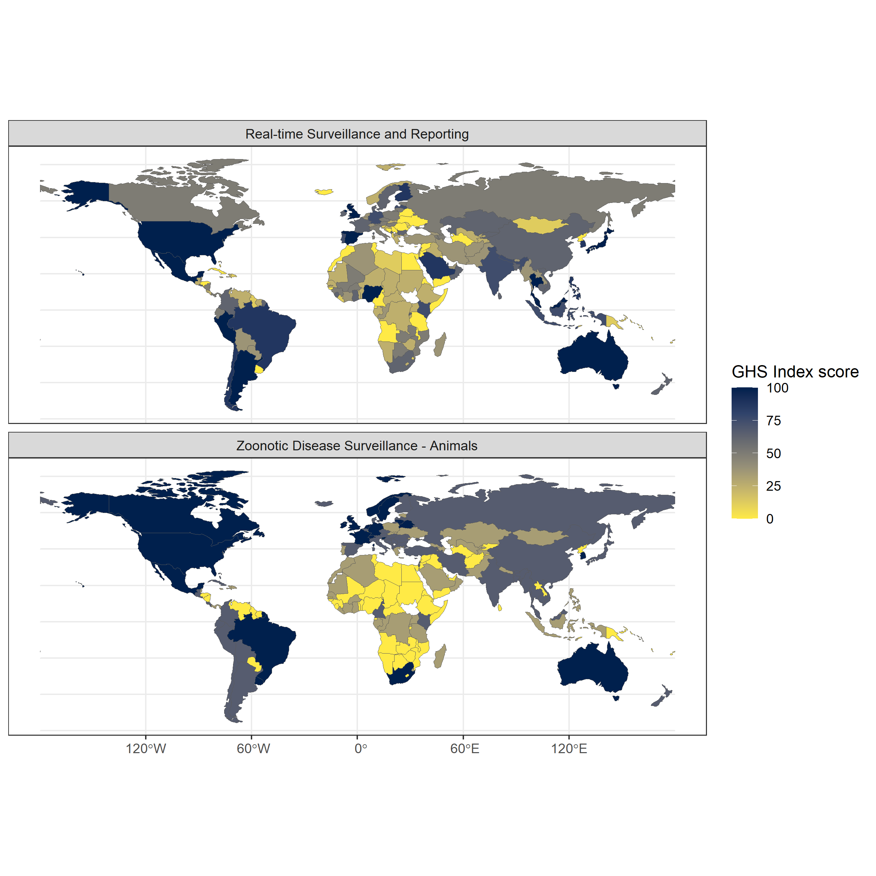

Figure 1.3 Global Health Security Index country scores for the sub-domains of 2.3) Real-time surveillance and reporting (top) and 1.2.2) Zoonotic disease surveillance (bottom). Real-time surveillance and reporting for epidemics of potential international concern is rated highly in several North and South American countries and countries in East and South East Asia and Oceania. Zoonotic disease surveillance in animals is rated highly in European, North and South American countries and Oceania. Generally surveillance for zoonotic infectious disease is limited across much of Africa, with the notable exception of Nigeria for real-time surveillance and reporting. Data obtained from the Global Health Security Index.

## Lassa fever: A case study of a rodent borne zoonosis in West Africa

The above sections have introduced zoonotic infectious diseases, the effect of a changing world on potential disease emergence, the role of rodents in zoonotic infectious disease transmission, and the particular risk of emergence and outbreaks in West Africa. The remainder of this introduction will focus on the case study of this thesis, Lassa fever, in West Africa and more specifically Sierra Leone.

### *Lassa mammarenavirus* and Lassa fever

*Lassa mammarenavirus* (LASV) is an enveloped, bisegmented, single stranded RNA virus of the Arenaviridae family. It is a zoonotic pathogen and is the causative agent of Lassa fever in humans. Lassa fever is a potentially lethal viral haemorrhagic fever, first identified from a case series of infected patients seeking healthcare in Jos, Nigeria in 1969 (Frame et al. 1970). Human LASV infection is caused by spillover of the virus from infected rodents and their excreta, with a limited role of human-to-human secondary transmission (McCormick et al. 1987; Lo Iacono et al. 2015). The primary host of LASV has been identified as the multimammate rat (*M. natalensis*) following an outbreak in Sierra Leone between 1970-2 (Monath et al. 1974). This synanthropic rodent species is found across much of sub-Saharan Africa, however, outside of West Africa, no individuals of this species have been found to be infected with LASV (Grobbelaar et al. 2021; Bellocq et al. 2020; Colangelo et al. 2013).

*Lassa mammarenavirus* has four confirmed lineages (I-IV) and three additional lineages (V-VII) based on geographic and phylogenetic analysis (Li 2023). Lineages I, II, III and VI are located within Nigeria; lineage IV contains all isolates from the Mano River region of Guinea, Liberia and Sierra Leone; lineage V contains samples from Mali and the Ivory Coast; and lineage VII contains recently sampled sequences from Togo (Ehichioya et al. 2019; Andersen et al. 2015; Manning, Forrester, and Paessler 2015; Whitmer et al. 2018). Lineage I is believed to be the most ancient, originating around 1,000 years ago in the North East of Nigeria, with subsequent radiation and establishment of lineages II and III in the Southern and Central areas of the country, respectively (Ehichioya et al. 2019; Andersen et al. 2015). Lineage IV represents a Westward expansion of the virus into the Mano River region, dated around 350 years ago (Andersen et al. 2015).

Host cell entry of the virus is mediated by a trimeric glycoprotein complex that interacts with host cell receptors and leads to fusion of the viral and host membranes, *in vivo* this protein undergoes substantial host-derived glycosylation, effectively reducing available antibody binding domains (Hastie and Saphire 2018). Once within the host cell, the viral nucleoprotein associates with viral RNAs forming ribonucleoprotein complexes facilitating transcription and replication of viral RNA within the host cell cytoplasm (Hass et al. 2004). The process of viral entry into host cells is expected to lead to the observed tissue tropism in experimental infection models in guinea pigs and *M. natalensis* (Torriani, Galan-Navarro, and Kunz 2017). Within infected guinea pigs and *M. natalensis,* LASV load was highest transiently in the lymph nodes with sustained high titres in the lungs and spleen (Jahrling et al. 1982; Safronetz et al. 2022). Minimal pathological changes were observed in guinea pigs or *M. natalensis*, with no evidence of clinical disease in these animals.

Among infected humans with clinical symptoms, the viral incubation period is between 7 and 18 days (McCormick et al. 1987). Initial symptoms are non-specific with fever, weakness, malaise, cough, sore throat and a typically frontal headache (Knobloch et al. 1980). The majority of symptomatic patients will go on to develop joint and lumbar pain, a non-productive cough with many developing severe retrosternal chest pain, nausea with vomiting and diarrhoea and abdominal pain (McCormick and Fisher-Hoch 2002). Up to a third of hospitalised patients will significantly decline 6-8 days post onset of fever with a minority developing haemorrhagic syndrome, with bleeding from the mucosal surfaces. Severe pulmonary oedema and soft tissue oedematous changes in the head and neck are common in fatal cases (Knobloch et al. 1980). The vast majority of infections, commonly reported as 80%, are asymptomatic, although in the absence of long-term prospective studies, the proportion of asymptomatic infections is difficult to estimate (McCormick et al. 1987). There is some limited evidence that disease severity may vary by infecting lineage (Garry 2023).

Treatment options for acute cases of Lassa fever are limited. Ribavirin is the standard of care for treating acute cases, although the effectiveness of this treatment is questionable (Salam et al. 2022). Supportive care therefore remains the mainstay of treatment for hospitalised individuals. There are no currently available vaccinations for Lassa fever, although three candidate vaccines have begun clinical trials (Salami et al. 2019; Inovio Pharmaceuticals 2022, 2020; International AIDS Vaccine Initiative 2023; Themis Bioscience GmbH 2022).

The case-fatality rate of Lassa fever has been reported to be as high as 29.7%, although this varies by country and year (Kenmoe et al. 2020). This estimate is based on a systematic review of the published scientific literature and does not include data from epidemiological reports or WHO bulletins. A recent review and integration of both epidemiological reports and the published literature to derive the case-fatality rate among confirmed cases in order to estimate the scale of underreporting in Lassa fever produced an estimated case-fatality rate of 16.5% (+/- 5%) among confirmed cases (Simons 2022). Importantly, this estimate is sensitive to biases in reporting and is likely a grossly inflated rate of mortality. Severe cases are more likely to come into contact with healthcare services and be tested for Lassa fever, and these cases are also more likely to result in disease associated mortality skewing confirmed cases to those with severe disease. Therefore, this case-fatality rate should be considered a severe disease case-fatality rate, with the majority of mildly symptomatic cases likely to have a dramatically reduced probability of mortality, whichwill lower the total case-fatality rate.

Survivors of symptomatic Lassa fever may have lasting effects of the disease. Sensorineural hearing loss is reported to occur in up to a third of Lassa fever survivors and potentially causes significant social and public health burden in the region that have not been well studied (Mateer et al. 2018). Additional neurological sequealae reported in Lassa fever survivors include cerebellar ataxia and visual impairment, although few patients have been assessed for these complications and progression over time is unclear (Li et al. 2020; Ezeomah et al. 2019). Most hospitalised patients, following recovery, rapidly clear viral RNA. Most patient sera are negative for viral RNA at hospital discharge, however, up to 50% of male survivors have detectable viral loads in seminal fluid at 3 months post-hospitalisation raising concerns that human-to-human sexual transmission may be possible(Thielebein et al. 2022).

### Lassa fever epidemiology

Annual Lassa fever incidence is unknown with estimates ranging between 150,000 to 4,300,000 cases per year annually (McCormick et al. 1987; Basinski et al. 2021). The wide uncertainty surrounding these estimates is due to a combination of few serological studies, limited disease surveillance and an overlap between the symptomatology of Lassa fever with other infectious diseases in these endemic regions (e.g., malaria). Lassa fever is currently considered endemic in 8 West African countries: Benin, Ghana, Guinea, Liberia, Mali, Nigeria, Sierra Leone and Togo by the World Health Organisation (WHO), with sporadic cases reported from Burkina Faso and the Ivory coast (Figure 1.4) (World Health Organisation 2022). The endemic region is entirely contained within the range of the primary reservoir species *M. natalensis*. Imported cases have been reported from non-West African countries such as the United Kingdom, Germany and the United States of America with few observed events of secondary human-to-human transmission outside of the endemic region (Tuite et al. 2019; Wolf et al. 2020).

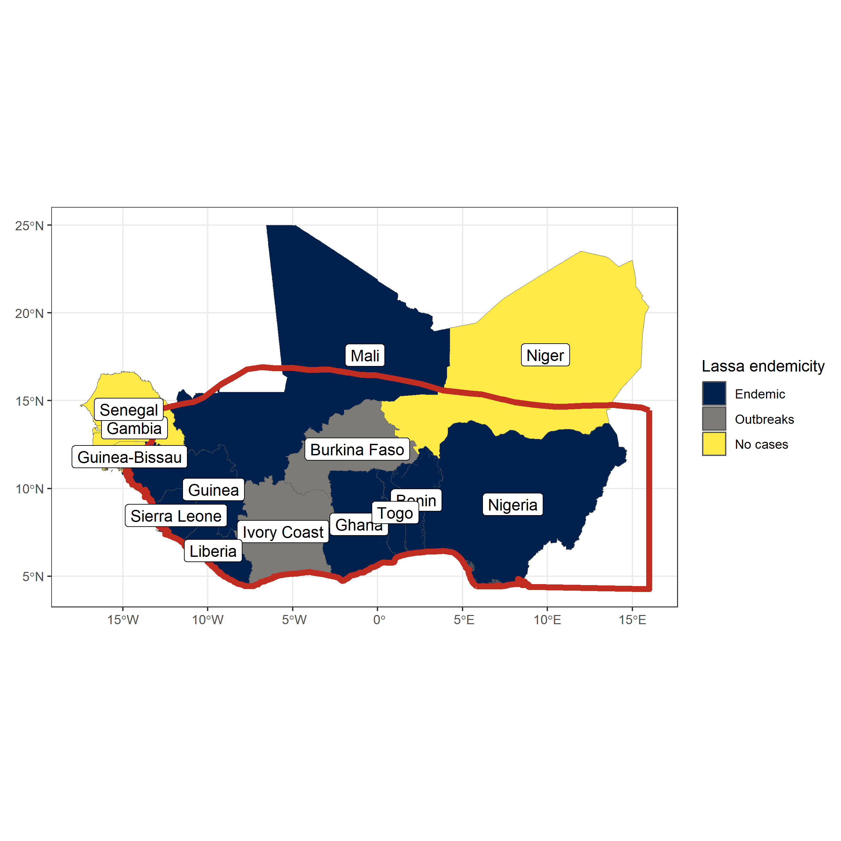

Figure 1.4 Lassa fever is considered endemic in eight West African countries, sporadic outbreaks have been reported from a further two countries within the region. The red border indicates the range of Mastomys natalensis in West Africa, its range extends East and South across the continent (not shown here). Data on Lassa fever endemicity is obtained from the WHO, data on Mastomys natalensis range is obtained from the International Union for Conservation of Nature Red List.

Nigeria and Sierra Leone have historically reported the greatest number of Lassa fever cases (Figure 1.5). This is likely driven by increased availability of testing for acute cases in these countries. Human seroepidemiological surveys in Guinea, Mali and the Ivory Coast – countries that have generally reported few acute cases – report seroprevalence in excess of 20%, which suggests undetected localised transmission of LASV (Kerneis et al. 2009; Bausch et al. 2001; Sogoba et al. 2016; Safronetz et al. 2017; Akoua-Koffi et al. 2006). The number of reported cases across the region declined during the Ebola and SARS-CoV-2 epidemic, where changes in healthcare seeking behaviour and availability of Lassa fever testing may have reduced. The number of cases reported in Nigeria has generally increased since data became routinely available in 2012. In contrast, there has been a dramatic fall in cases reported from Sierra Leone since 2012. Whether these trends represent actual changes in the underlying spillover risk remains unclear.

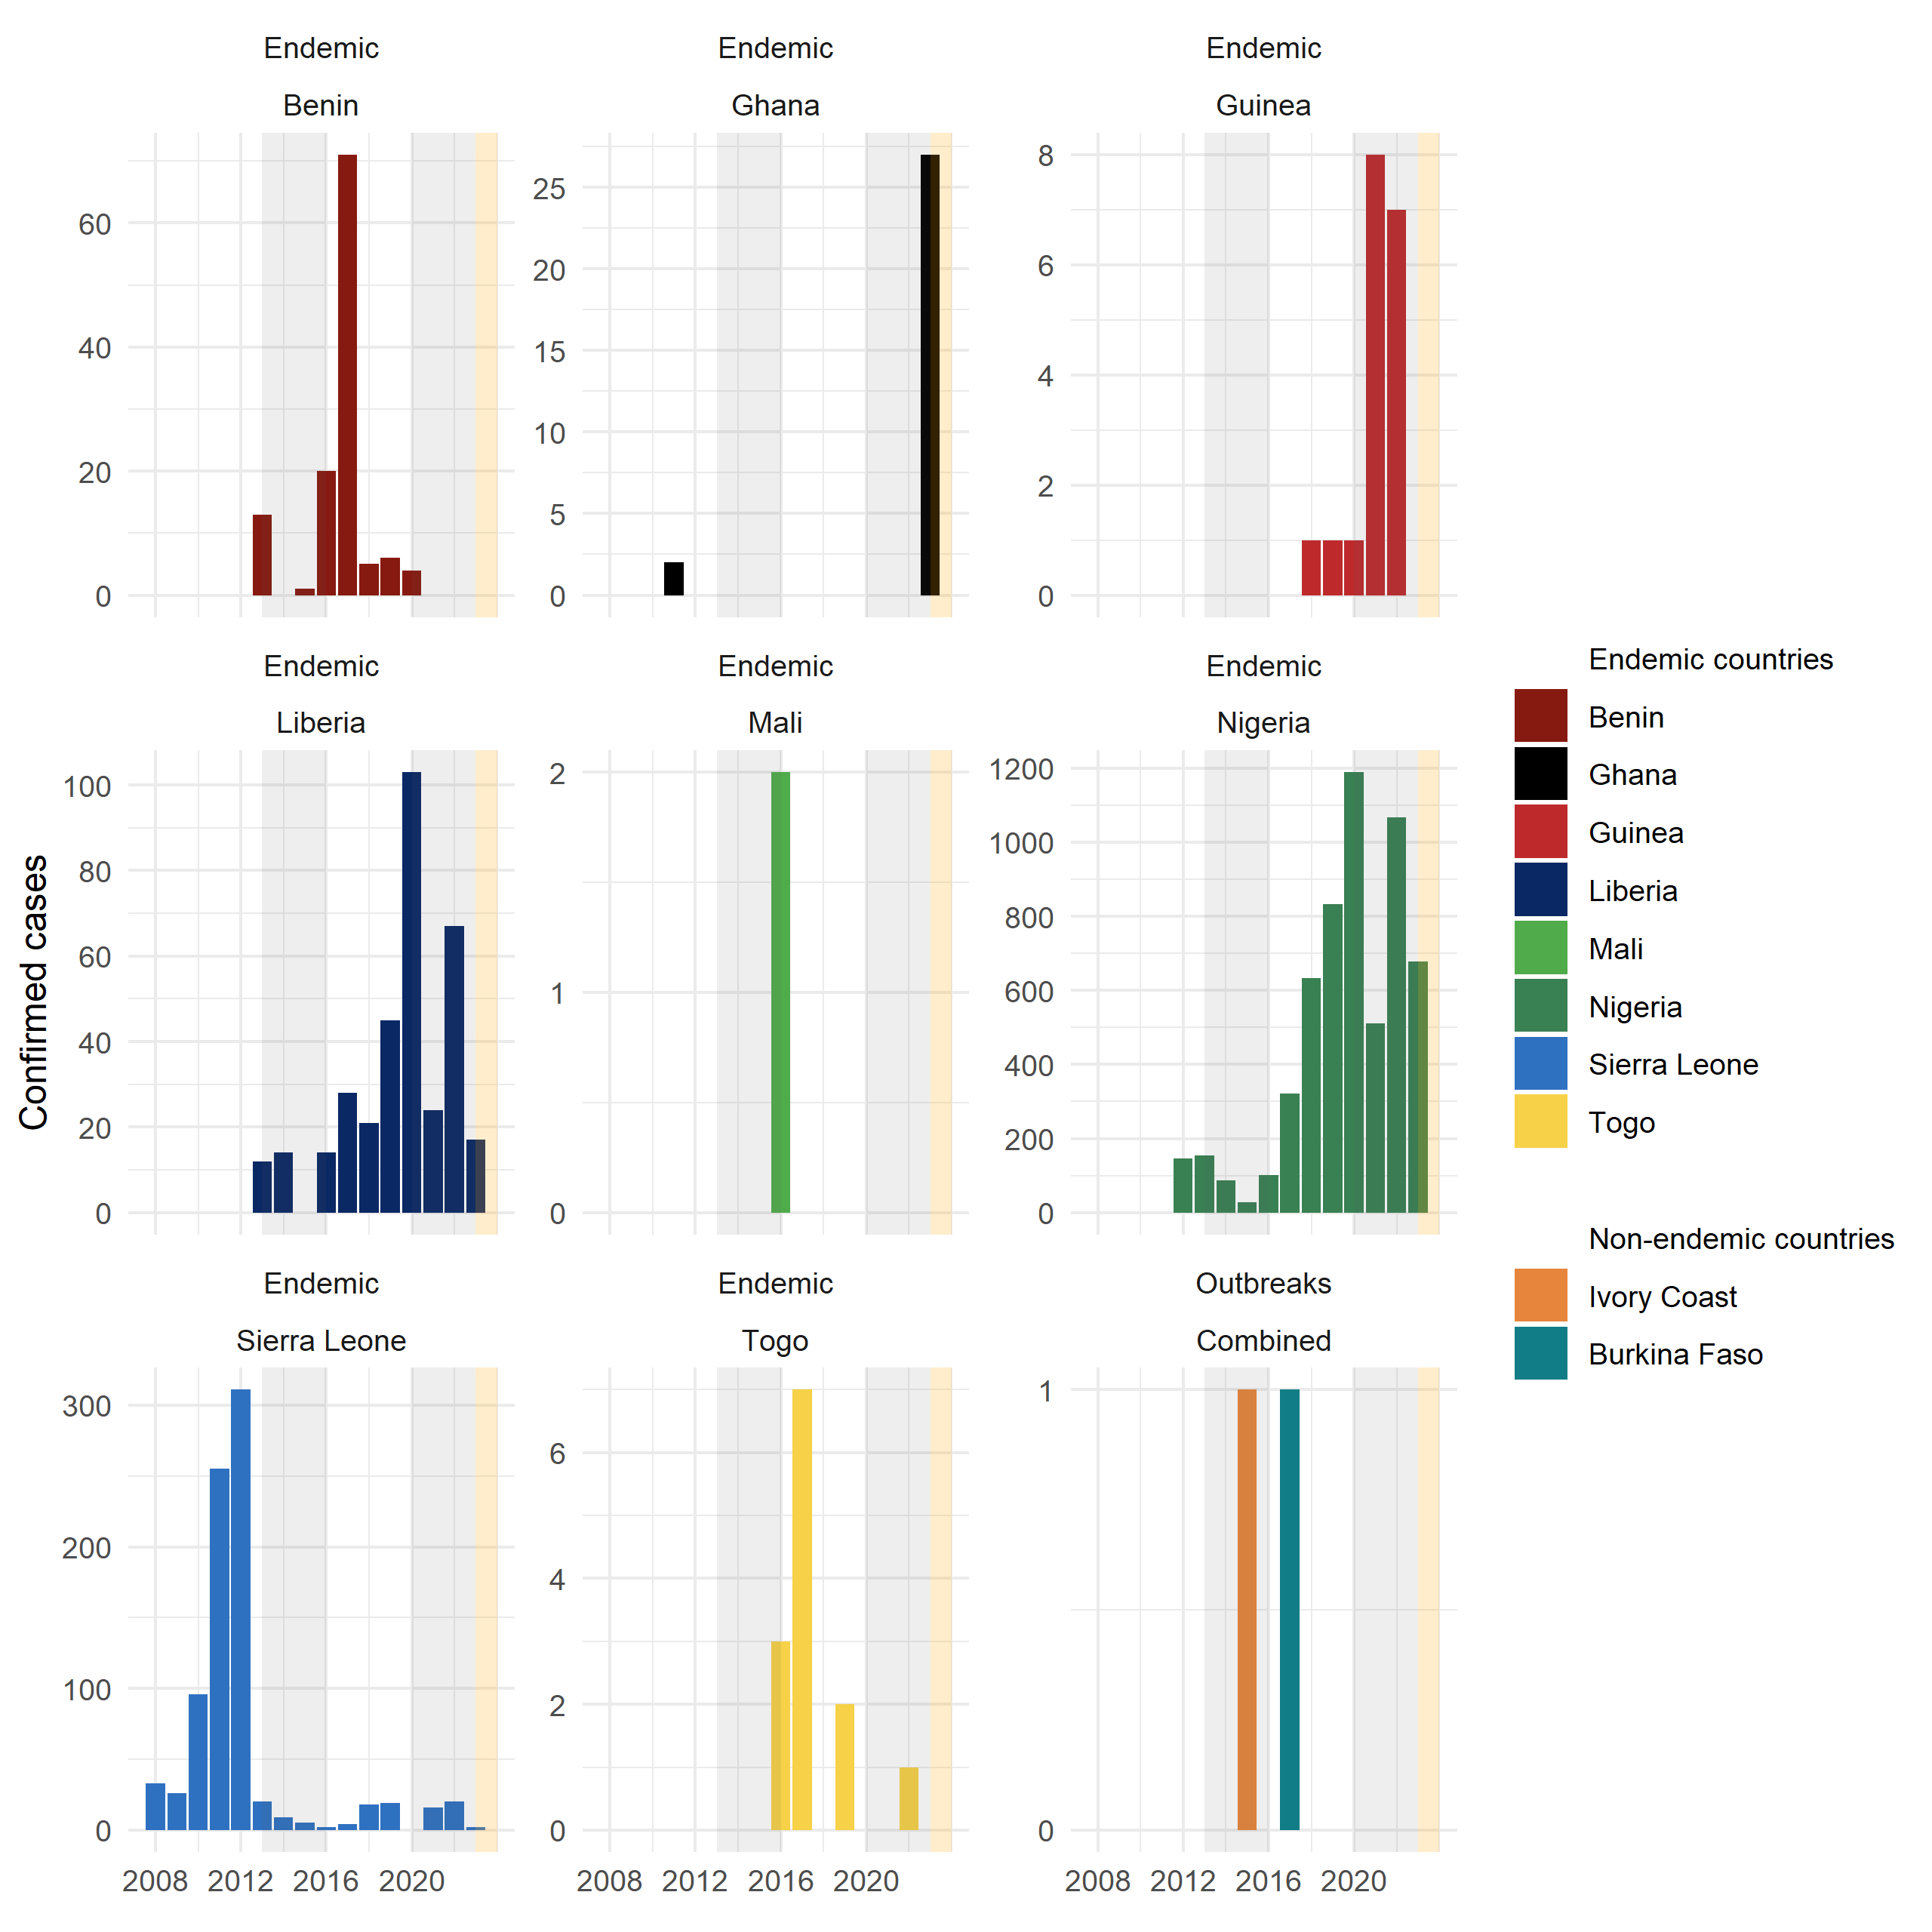

Figure 1.5 Confirmed Lassa fever cases from countries in West Africa 2008-2023. Confirmed cases show variability by year with the greatest number of cases reported from Nigeria, Sierra Leone and Liberia. Grey shaded regions represent periods of regional or global epidemics which may have affected Lassa fever reporting (i.e., the Ebola epidemic and SARS-CoV-2 pandemic). The yellow shaded region represents 2023 where an incomplete year is shown. Data compiled from multiple sources.

The number of reported confirmed cases of Lassa fever in endemic countries is likely to be significantly underreported. Cases tend to occur in rural and remote locations where healthcare access is generally low, and financial and societal costs of accessing healthcare relatively high while testing facilities are concentrated in large urban settings (Bhadelia 2019; Nnaji et al. 2021). Additionally, while clinicians in endemic settings have good awareness of symptoms that may indicate acute Lassa fever infection, access to testing and timely reporting were identified as factors that could lead to diagnostic delay, poor patient outcomes and delayed public health responses to outbreaks (Olowookere et al. 2014; Rohan 2022). An estimate of the degree of underreporting was conducted using reported Lassa fever disease associated mortality, assuming a consistent 16.5% case-fatality rate across the region. Using this approach, Nigeria was found to report the highest proportion of all expected cases (63%) while countries with generally fewer observed outbreaks reported significantly fewer than expected cases (e.g., Ghana - 17%, Guinea - 25%) (Simons 2022).

Human seroepidemiological studies conducted in several regions of Sierra Leone suggest that despite the observed fall in human cases of disease infection remains prevalent (Grant et al. 2023). This study in Sierra Leone also suggests that widespread transmission of LASV is occurring outside the traditionally considered endemic region of Eastern Sierra Leone. A large-scale serological study conducted by the Coalition for Epidemic Preparedness Innovations across Benin, Guinea, Liberia, Nigeria and Sierra Leone to understand the prevalence to antibodies against LASV has been implemented and results are awaiting (Penfold et al. 2023).

### Rodent hosts of *Lassa mammarenavirus*

While *M. natalensis* is considered the primary reservoir of LASV, 11 other rodent species have been found to be acutely infected or have antibodies to the virus (Simons et al. 2023). The role of the wider rodent species community in viral transmission in endemic areas is not currently well understood. Further, evidence exists for prior exposure to LASV in non-rodent species, including domestic dogs, non-human primates and shrews. The role of these species in the ecology of LASV is even less clear (Kenmoe et al. 2020).

*M. natalensis* is a synanthropic rodent species, native to Africa. This species is considered a pest species across much of its range, as it lives within and around human communities consuming grain within the fields and in stores (Swanepoel et al. 2017). The species demonstrates archetypal fast life history traits with rapid sexual maturity (4 months), short life span (<1 year) and large litter sizes (mean of 9 live offspring) (Coetzee 1975; Albery and Becker 2021; Safronetz et al. 2021). The proportion of reproductively active individuals is observed to increase in the late wet season and early dry season, with a nadir in the late dry season, leading to a population boom in the late wet season (Mlyashimbi et al. 2018; Mayamba et al. 2021). Importantly, the majority of population dynamic studies in this species have been conducted in Tanzania, where abundance has been observed to be closely linked to food availability. However, the drivers of these population dynamics may not be as extreme in West Africa where the population dynamics are less closely linked to rainfall patterns (Olayemi et al. 2018; Fichet-Calvet et al. 2008; Bangura et al. 2021).

As a synanthropic species, *M. natalensis* typically occurs within areas of human habitation and agriculture and is found to be an early invader of land converted to agricultural use (Makundi, Massawe, and Mulungu 2007). This land use preference is consistent across the entirety of its range, with few individuals trapped in forested landscapes (Olayemi et al. 2018; Fichet-Calvet et al. 2008; Bangura et al. 2021; Coetzee 1975; Leirs, Verheyen, and Verhagen 1996). This would suggest that abundance of this species is heterogeneous across its range with expected absence in the forested regions of sub-Saharan Africa. This species is non-territorial, co-existing with conspecifics and other rodent species and with a limited home range of ~30m, although, dispersal across greater distances has been observed (Leirs, Verheyen, and Verhagen 1996). Contact with other rodent species is assumed to be common and this is reflected by the high rodent species richness in locations where *M. natalensis* is detected (Fichet-Calvet et al. 2008; Bangura et al. 2021). The high frequency of contacts may be potentially important for the transmission of LASV among rodent hosts as it potentially facilitates transmission of the virus across the heterogeneous land use types of the endemic region.

While this species is distributed across sub-Saharan Africa, genomic studies suggest that six phylogroups (A-I to A-III and B-IV to B-VI) have formed, which correspond to different geographic regions of Africa. The West African clade, A-I is genetically distinct and is found in the endemic region of LASV (Colangelo et al. 2013). Individuals of the other clades have not been found to be infected with LASV but have tested positive for other Arenaviridae, including Mayo Ranewo (A-II), Dhati Welel (A-III), Gairo (B-IV), Morogoro (B-V), and Mopeia viruses (B-VI) (Bellocq et al. 2020). The presence of clade specific Arenaviridae may explain why the Lassa fever endemic region is constrained to the Western radiation of *M. natalensis* despite it being found throughout sub-Saharan Africa and may limit any future geographic expansion of the virus.

While LASV is considered to primarily infect *M. natalensis,* the prevalence of LASV in rodent communities varies importantly across the region and over time. Figure 1.6 shows the prevalence of acute infection or antibodies to LASV among sampled *M. natalensis* communities. When detected, LASV prevalence varies both within and between countries. In Guinea, LASV was detected in 10 to 55% of trapped individual rodents. In a single study conducted in Mali, acute infection was detected in 25% of individuals, while in Sierra Leone, sampled rodents showed a wide range of prevalence from 5% to 100%. However most of the sampling events in these settings did not detect any acute infection (not shown in Figure 1.6). The number of individuals tested for acute infection is typically lower than those tested for antibodies due to availability of reagents, cost and laboratory requirements. There are also selection biases in which rodents are tested for acute infection which may increase the proportion of positive samples. For example, testing may only be performed in antibody positive rodents or rodents trapped in the location of a confirmed human case.

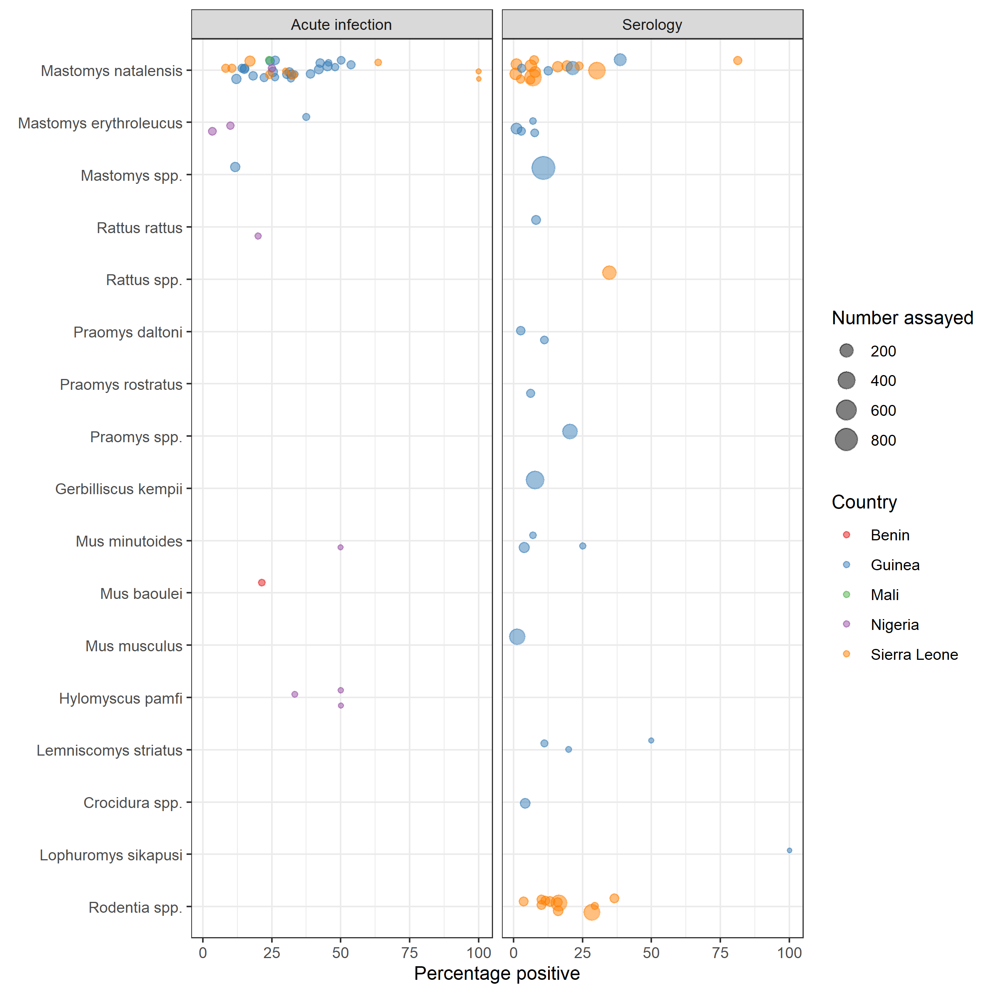

Figure 1.6 Prevalence of acute infection with LASV or antibodies to LASV in rodent species sampled in West Africa. The size of a point relates to the number of samples of that species tested and the colour to the country in which the rodent was sampled. Where possible the rodent species is identified, for individuals only identified to genus level the genera from which samples obtained is shown. Six rodent species have been found to be acutely infected with LASV with 10 species having detectable antibodies. The majority of samples have been obtained from rodents trapped in Guinea and Sierra Leone. Data obtained from (Will add in all the references)

Figure 1.6 also highlights the detection of LASV in non-*M. natalensis* species. *Mastomys erythroleucus* a morphologically indistinguishable, closely related species to *M. natalensis* has been found to co-occur with *M. natalensis* in several regions of Guinea, Sierra Leone and Nigeria (Brouat et al. 2009). The proportion of *M. erythroleucus* individuals found to be infected with LASV was not too dissimilar from *M. natalensis* and may indicate that this species can also be involved in viral transmission in locations where these species co-exist. Three other native rodent species, *Mus minutoides*, *Mus baoulei* and *Hylomyscus pamfi,* have been found to be acutely infected with LASV although the number of individuals of these tested is small. *Mus minutoides* and *Mus baoulei* are African pygmy mice – i.e., a complex of 17-19 morphologically similar rodents that may contain a number of undescribed subspecies (Britton-Davidian, Robinson, and Veyrunes 2012). They occupy a wide range of land use types and are not considered synanthropic, with preference for forest and shrubland habitats, although they are often detected in cultivated landscapes (Long et al. 2013). Finally, the non-native, invasive rodent species, *Rattus rattus,* has been found to be acutely infected with LASV. This synanthropic rodent species co-occurs with *M. natalensis* in locations which it has invaded and may represent a relatively recent host of LASV within the endemic region (Olayemi et al. 2018; Bangura et al. 2021).

More rodent species have been found to have antibodies to LASV than those found to have acute infection. Whether these species are competent hosts of the virus and are able to produce subsequent rodent-to-rodent or rodent-to-human transmission is not known. Additionally, some of these detections may be due to the presence of cross-reactive antibodies to other Arenaviridae; however, a validated, commercial ELISA assay used for many of these surveys shows a sensitivity of 97.1% and specificity of 100% to LASV (Soubrier et al. 2022). The proportion of all samples that tested positive for LASV antibodies across all species is typically lower, consistent with the greater number of samples assayed and less targeted sampling. Additional species found to have antibodies to LASV include the native rodents *Praomys daltoni*, *Praomys rostratus*, *Lemniscomys striatus*, *Lophuromys sikapusi* and *Gerbilliscus kempii*. Of these species, only *P. daltoni* is considered synanthropic, typically found in villages and nearby agricultural areas in West Africa (Nicolas et al. 2008; Mikula et al. 2020). *P. rostratus* and *L. sikapusi* are more commonly found in forested or fragmented forest, shrubland and agricultural habitats (Félix Houphouët-Boigny University, Côte d’Ivoire et al. 2018; Iyawe 1988). *L. striatus* and *G. kempii* are considered savannah rodents, rarely detected within villages but often detected in forested habitats, shrubland and agriculture (Hoffmann and Klingel 2001; Lourie et al. 1975; Davis 1949). Finally, non-rodent species found to have antibodies to LASV include individuals of the species rich insectivorous shrew order (*Crocidura spp.*). As morphological identification to species level is typically not performed the grouping is at the order level.

Two invasive rodent species, *Mus musculus* and *R. rattus* are increasingly common in West Africa. These species have been introduced through human activity, typically in coastal regions, beginning in the 15th century with subsequent expansion into the interior of countries along human transport networks (Dalecky et al. 2015). Populations of these species have been found to establish communities in areas of human habitation demonstrating their synanthropic properties (Puckett, Orton, and Munshi-South 2020; Hima et al. 2019). These species appear to have different effects on local species richness following establishment with *M. musculus* but not *R. rattus* leading to reduced rodent species richness in locations in which it is detected (Dalecky et al. 2015). This may have important implications for the prevalence of LASV in the endemic region: if displacement of the primary reservoir by these invasive species that are potentially less competent hosts of viral transmission, the risk of Lassa fever outbreaks may subsequently decrease.

Sampling of rodent species and locations of confirmed human cases have been used to produce risk maps of Lassa fever outbreaks. Risk maps may be based on human cases, *M. natalensis* occurrence or a combination of both. These risk maps consistently identify the Mano River region and Nigeria as hotspots of risk (Basinski et al. 2021; Gibb et al. 2017; Mylne et al. 2015; Fichet-Calvet and Rogers 2009). The studies are conducted at the regional scale and are not able to incorporate the heterogeneity of rodent species occurrence or abundance that has been observed in rodent sampling studies. The potential contribution of wider rodent communities to viral transmission or maintenance is not incorporated in these models as they all consider *M. natalensis* as the sole reservoir of LASV.

Importantly, sampling of rodents and LASV in West Africa is biased taxonomically and geographically, with increased sampling effort in locations reporting historical outbreaks of Lassa fever (Beck et al. 2014; Klitting et al. 2022). Limiting sampling to these locations may be artificially biasing risk towards these regions, with a study accounting for some of these biases suggesting that risk is more evenly distributed across West Africa than what has historically been reported (Peterson, Moses, and Bausch 2014). A better understanding of sampling biases in both small mammal communities and pathogen sampling will assist in identifying regions in which additional sampling is required. Further, predicting future change in risk that could ensue from ongoing global change will be limited by data suffering from these biases (Boria et al. 2014; Wille, Geoghegan, and Holmes 2021).

## Thesis aims and structure

To better understand the current and future risk of Lassa fever spillover in West Africa, biases in available data need to be characterised and systematic sampling of the entire rodent community is required. This thesis aimed to address some of the critical gaps in understanding of LASV transmission among rodent communities in endemic settings and the effect of anthropogenic change on the structure of rodent communities and how this may modulate Lassa fever spillover risk.

The first part of this thesis (Chapter 2) attempts to understand a key problem in the sampling of both rodents and their pathogens across West Africa. The research question Chapter 2 seeks to address is whether the sampling bias of rodents and linked pathogens can be quantified and mitigated against. To achieve this, a scoping review of rodent trapping studies in West Africa was conducted. Findings were synthesised and assessed for spatial biases, identifying regions that have been relatively under-sampled and therefore locations in which inference may be limited based on available datasets. This dataset was subsequently compared witha commonly used resource, the Global Biodiversity Information Facility (GBIF), to explore the benefit of incorporating primary rodent trapping data within this larger, consolidated dataset. The results presented in this chapter and the planned incorporation of these data into GBIF will aid researchers attempting to model risks of rodent borne zoonoses in West Africa and the effect of future anthropogenic change on rodent distributions across the region.

The second part of this thesis (Chapter 3 and 4) present the results of a systematic study of rodent ecology and LASV prevalence in an endemic region of Eastern Sierra Leone. Following primary data collection in the form of a series of rodent trapping studies, chapter 3 describes the composition of rodent communities in Eastern Sierra Leone and aims to address the question as to whether rodent species richness and diversity vary along an anthropogenic land use gradient. This study explores the biotic interactions between rodent species to infer the risk of LASV transmission among rodent communities along a land use gradient using species occupancy models which account for incomplete detection. Chapter 4 expands on this work to explicitly model potential contact networks among individual rodents in different land use types to investigate the interactions within these rodent communities. The key research question addressed is whether the primary reservoir is more likely to interact with members of the same species and what consequences this may havefor viral transmission. I use Exponential Random Graph Models fitted to produced networks of rodent contacts based on rodent trapping data to assess the probability of inter- and intra-specific contact rates to understand viral transmission within rodent communities. This chapter describes the prevalence of antibodies to LASV to gauge the risk of Lassa fever spillover in these settings.

The thesis concludes with a discussion of how insights from this body of work enhance our understanding of the risk of rodent borne zoonoses in West Africa in general, and Lassa fever emergence in Sierra Leone in particular. Future directions of study required to better quantify this dynamic risk are discussed, alongside how dynamic risk estimates can guide timely public health interventions to reduce disease associated morbidity and mortality.

“About PREDICT. School of Veterinary Medicine.” 2019. January 17, 2019. <https://ohi.sf.ucdavis.edu/programs-projects/predict-project/about>.

Akoua-Koffi, C, J Ter Meulen, D Legros, V Akran, M Aïdara, N Nahounou, P Dogbo, and A Ehouman. 2006. “[[Detection of Anti-Lassa Antibodies in the Western Forest Area of the Ivory Coast]](https://www.ncbi.nlm.nih.gov/pubmed/17201291).” *Medecine Tropicale* 66 (5): 465–68.

Albery, Gregory F., and Daniel J. Becker. 2021. “Fast-Lived Hosts and Zoonotic Risk.” *Trends in Parasitology* 37 (2): 117–29. <https://doi.org/10.1016/j.pt.2020.10.012>.

Amman, Brian R., Brian H. Bird, Ibrahim A. Bakarr, James Bangura, Amy J. Schuh, Jonathan Johnny, Tara K. Sealy, et al. 2020. “Isolation of Angola-Like Marburg Virus from Egyptian Rousette Bats from West Africa.” *Nature Communications* 11 (1): 510. <https://doi.org/10.1038/s41467-020-14327-8>.

Andersen, Kristian G., B. Jesse Shapiro, Christian B. Matranga, Rachel Sealfon, Aaron E. Lin, Lina M. Moses, Onikepe A. Folarin, et al. 2015. “Clinical Sequencing Uncovers Origins and Evolution of Lassa Virus.” *Cell* 162 (4): 738–50. <https://doi.org/10.1016/j.cell.2015.07.020>.

Bangura, Umaru, Jacob Buanie, Joyce Lamin, Christopher Davis, Gedeon Ngiala Bongo, Michael Dawson, Rashid Ansumana, et al. 2021. “Lassa Virus Circulation in Small Mammal Populations in Bo District, Sierra Leone.” *BIOLOGY-BASEL* 10 (1). <https://doi.org/10.3390/biology10010028>.

Basinski, Andrew J., Elisabeth Fichet-Calvet, Anna R. Sjodin, Tanner J. Varrelman, Christopher H. Remien, Nathan C. Layman, Brian H. Bird, et al. 2021. “Bridging the Gap: Using Reservoir Ecology and Human Serosurveys to Estimate Lassa Virus Spillover in West Africa.” Edited by Amy Wesolowski. *PLOS Computational Biology* 17 (3): e1008811. <https://doi.org/10.1371/journal.pcbi.1008811>.

Bausch, D. G., A. H. Demby, M. Coulibaly, J. Kanu, A. Goba, A. Bah, N. Condé, et al. 2001. “Lassa Fever in Guinea: I. Epidemiology of Human Disease and Clinical Observations.” *Vector Borne and Zoonotic Diseases (Larchmont, N.Y.)* 1 (4): 269–81. <https://doi.org/10.1089/15303660160025903>.

Beck, Jan, Marianne Böller, Andreas Erhardt, and Wolfgang Schwanghart. 2014. “Spatial Bias in the GBIF Database and Its Effect on Modeling Species’ Geographic Distributions.” *Ecological Informatics* 19 (January): 10–15. <https://doi.org/10.1016/j.ecoinf.2013.11.002>.

Bellocq, Joëlle Goüy De, Anna Bryjová, Aleksey A. Martynov, and Leonid A. Lavrenchenko. 2020. “Dhati Welel Virus, the Missing Mammarenavirus of the Widespread Mastomys Natalensis.” *Journal of Vertebrate Biology* 69 (2): 20018.1. <https://doi.org/10.25225/jvb.20018>.

Bhadelia, Nahid. 2019. “Understanding Lassa Fever.” *Science* 363 (6422): 30–30. <https://doi.org/10.1126/science.aav8958>.

Bongaarts, John. 2009. “Human Population Growth and the Demographic Transition.” *Philosophical Transactions of the Royal Society B: Biological Sciences* 364 (1532): 2985–90. <https://doi.org/10.1098/rstb.2009.0137>.

Boria, Robert A., Link E. Olson, Steven M. Goodman, and Robert P. Anderson. 2014. “Spatial Filtering to Reduce Sampling Bias Can Improve the Performance of Ecological Niche Models.” *Ecological Modelling* 275 (March): 73–77. <https://doi.org/10.1016/j.ecolmodel.2013.12.012>.

Britton-Davidian, J., T. J. Robinson, and F. Veyrunes. 2012. “Systematics and Evolution of the African Pygmy Mice, Subgenus Nannomys: A Review.” *Acta Oecologica*, Biodiversity and global change in southern africa, 42 (July): 41–49. <https://doi.org/10.1016/j.actao.2012.01.001>.

Brouat, Carine, Caroline Tatard, Khalilou Bâ, Jean-François Cosson, Gauthier Dobigny, Elisabeth Fichet-Calvet, Laurent Granjon, et al. 2009. “Phylogeography of the Guinea Multimammate Mouse (Mastomys Erythroleucus): A Case Study for Sahelian Species in West Africa.” *Journal of Biogeography* 36 (12): 2237–50. <https://doi.org/10.1111/j.1365-2699.2009.02184.x>.

Carlson, Colin J., Gregory F. Albery, Cory Merow, Christopher H. Trisos, Casey M. Zipfel, Evan A. Eskew, Kevin J. Olival, Noam Ross, and Shweta Bansal. 2022. “Climate Change Increases Cross-Species Viral Transmission Risk.” *Nature* 607 (7919): 555–62. <https://doi.org/10.1038/s41586-022-04788-w>.

Ceballos, Gerardo, and Paul R. Ehrlich. 2006. “Global Mammal Distributions, Biodiversity Hotspots, and Conservation.” *Proceedings of the National Academy of Sciences* 103 (51): 19374–79. <https://doi.org/10.1073/pnas.0609334103>.

Civitello, David J., Jeremy Cohen, Hiba Fatima, Neal T. Halstead, Josue Liriano, Taegan A. McMahon, C. Nicole Ortega, et al. 2015. “Biodiversity Inhibits Parasites: Broad Evidence for the Dilution Effect.” *Proceedings of the National Academy of Sciences* 112 (28): 8667–71. <https://doi.org/10.1073/pnas.1506279112>.

Cleaveland, S., M. K. Laurenson, and L. H. Taylor. 2001. “Diseases of Humans and Their Domestic Mammals: Pathogen Characteristics, Host Range and the Risk of Emergence.” Edited by M. E. J. Woolhouse and C. Dye. *Philosophical Transactions of the Royal Society of London. Series B: Biological Sciences* 356 (1411): 991–99. <https://doi.org/10.1098/rstb.2001.0889>.

Coetzee, Cornelius G. 1975. “The Biology, Behaviour, and Ecology of Mastomys Natalensis in Southern Africa.” *Bulletin of the World Health Organization* 52 (4): 637–44. <https://www.ncbi.nlm.nih.gov/pmc/articles/PMC2366655/>.

Colangelo, Paolo, Erik Verheyen, Herwig Leirs, Caroline Tatard, Christiane Denys, Gauthier Dobigny, Jean-Marc Duplantier, Carine Brouat, Laurent Granjon, and Emilie Lecompte. 2013. “A Mitochondrial Phylogeographic Scenario for the Most Widespread African Rodent, Mastomys Natalensis.” *Biological Journal of the Linnean Society* 108 (4): 901–16. <https://doi.org/10.1111/bij.12013>.

D’Elía, Guillermo, Pierre-Henri Fabre, and Enrique P Lessa. 2019. “Rodent Systematics in an Age of Discovery: Recent Advances and Prospects.” *Journal of Mammalogy* 100 (3): 852–71. <https://doi.org/10.1093/jmammal/gyy179>.

Dalecky, Ambroise, Khalilou Ba, Sylvain Piry, Cedric Lippens, Christophe A. Diagne, Mamadou Kane, Aliou Sow, et al. 2015. “Range Expansion of the Invasive House Mouse Mus Musculus Domesticus in Senegal, West Africa: A Synthesis of Trapping Data over Three Decades, 1983-2014.” *Mammal Review* 45 (3): 176–90. <https://doi.org/10.1111/mam.12043>.

Dalhat, Mahmood M., Adebola Olayinka, Martin M. Meremikwu, Chioma Dan-Nwafor, Akanimo Iniobong, Lorretta F. Ntoimo, Ikenna Onoh, et al. 2022. “Epidemiological Trends of Lassa Fever in Nigeria, 2018–2021.” *PLOS ONE* 17 (12): e0279467. <https://doi.org/10.1371/journal.pone.0279467>.

Daszak, P., A. A. Cunningham, and A. D. Hyatt. 2001. “Anthropogenic Environmental Change and the Emergence of Infectious Diseases in Wildlife.” *Acta Tropica* 78 (2): 103–16. <https://doi.org/10.1016/S0001-706X(00)00179-0>.

Davis, D.h.s. 1949. “The Affinities of the South African Gerbils of the Genus Tatera.” *Proceedings of the Zoological Society of London* 118 (4): 1002–18. <https://doi.org/10.1111/j.1096-3642.1949.tb00417.x>.

Dudas, Gytis, Luiz Max Carvalho, Andrew Rambaut, and Trevor Bedford. 2018. “MERS-CoV Spillover at the Camel-Human Interface.” Edited by Neil M Ferguson. *eLife* 7 (January): e31257. <https://doi.org/10.7554/eLife.31257>.

Ecke, Frauke, Barbara A. Han, Birger Hörnfeldt, Hussein Khalil, Magnus Magnusson, Navinder J. Singh, and Richard S. Ostfeld. 2022. “Population Fluctuations and Synanthropy Explain Transmission Risk in Rodent-Borne Zoonoses.” *Nature Communications* 13 (1): 7532. <https://doi.org/10.1038/s41467-022-35273-7>.

Editors, ed. 2011. “Microbiology by Numbers.” *Nature Reviews Microbiology* 9 (9): 628–28. <https://doi.org/10.1038/nrmicro2644>.

Ehichioya, Deborah U., Simon Dellicour, Meike Pahlmann, Toni Rieger, Lisa Oestereich, Beate Becker-Ziaja, Daniel Cadar, et al. 2019. “Phylogeography of Lassa Virus in Nigeria.” *Journal of Virology* 93 (21): e00929–19. <https://doi.org/10.1128/JVI.00929-19>.

Epstein, Jonathan H., Hume E. Field, Stephen Luby, Juliet R. C. Pulliam, and Peter Daszak. 2006. “Nipah Virus: Impact, Origins, and Causes of Emergence.” *Current Infectious Disease Reports* 8 (1): 59–65. <https://doi.org/10.1007/s11908-006-0036-2>.

Ezeomah, Chiomah, Adeyi Adoga, Chikwe Ihekweazu, Slobodan Paessler, Irma Cisneros, Oyewale Tomori, and David Walker. 2019. “Sequelae of Lassa Fever: Postviral Cerebellar Ataxia.” *Open Forum Infectious Diseases* 6 (12): ofz512. <https://doi.org/10.1093/ofid/ofz512>.

Fagre, Anna C., Lily E. Cohen, Evan A. Eskew, Max Farrell, Emma Glennon, Maxwell B. Joseph, Hannah K. Frank, Sadie J. Ryan, Colin J Carlson, and Gregory F. Albery. 2022. “Assessing the Risk of Human-to-Wildlife Pathogen Transmission for Conservation and Public Health.” *Ecology Letters* 25 (6): 1534–49. <https://doi.org/10.1111/ele.14003>.

Farooq, Zia, Joacim Rocklöv, Jonas Wallin, Najmeh Abiri, Maquines Odhiambo Sewe, Henrik Sjödin, and Jan C. Semenza. 2022. “Artificial Intelligence to Predict West Nile Virus Outbreaks with Eco-Climatic Drivers.” *The Lancet Regional Health - Europe* 17 (June): 100370. <https://doi.org/10.1016/j.lanepe.2022.100370>.

Félix Houphouët-Boigny University, Côte d’Ivoire, Bertin K. Akpatou, Kouakou H. Bohoussou, University of Man, Côte d’Ivoire, Blaise Kadjo, Félix Houphouët-Boigny University, Côte d’Ivoire, Violaine Nicolas, and National Museum of Natural History of Paris, France. 2018. “Terrestrial Small Mammal Diversity and Abundance in Taï National Park, Côte d’ivoire.” *Nature Conservation Research* 3. <https://doi.org/10.24189/ncr.2018.067>.

Fichet-Calvet, Elisabeth, Emilie Lecompte, Lamine Koivogui, Stéphane Daffis, and Jan ter Meulen. 2008. “Reproductive Characteristics of Mastomys Natalensis and Lassa Virus Prevalence in Guinea, West Africa.” *Vector Borne and Zoonotic Diseases (Larchmont, N.Y.)* 8 (1): 41–48. <https://doi.org/10.1089/vbz.2007.0118>.

Fichet-Calvet, Elisabeth, and David John Rogers. 2009. “Risk Maps of Lassa Fever in West Africa.” *PLOS Neglected Tropical Diseases* 3 (3): e388. <https://doi.org/10.1371/journal.pntd.0000388>.

Fine, P E M, Z Jezek, B Grab, and H Dixon. 1988. “The Transmission Potential of Monkeypox Virus in Human Populations.” *International Journal of Epidemiology* 17 (3): 643–50. <https://doi.org/10.1093/ije/17.3.643>.

Fischer, Christina, Christoph Gayer, Kornélia Kurucz, Friederike Riesch, Teja Tscharntke, and Péter Batáry. 2018. “Ecosystem Services and Disservices Provided by Small Rodents in Arable Fields: Effects of Local and Landscape Management.” *Journal of Applied Ecology* 55 (2): 548–58. <https://doi.org/10.1111/1365-2664.13016>.

Frame, John D., John M. Baldwin, David J. Gocke, and Jeanette M. Troup. 1970. “Lassa Fever, a New Virus Disease of Man from West Africa: I. Clinical Description and Pathological Findings.” *The American Journal of Tropical Medicine and Hygiene* 19 (4): 670–76. <https://doi.org/10.4269/ajtmh.1970.19.670>.

Garry, Robert F. 2023. “Lassa Fever — the Road Ahead.” *Nature Reviews Microbiology* 21 (2): 87–96. <https://doi.org/10.1038/s41579-022-00789-8>.

Gibb, Rory, Gregory F Albery, Daniel J Becker, Liam Brierley, Ryan Connor, Tad A Dallas, Evan A Eskew, et al. 2021. “Data Proliferation, Reconciliation, and Synthesis in Viral Ecology.” *BioScience* 71 (11): 1148–56. <https://doi.org/10.1093/biosci/biab080>.

Gibb, Rory, Gregory F. Albery, Nardus Mollentze, Evan A. Eskew, Liam Brierley, Sadie J. Ryan, Stephanie N. Seifert, and Colin J. Carlson. 2021. “Mammal Virus Diversity Estimates Are Unstable Due to Accelerating Discovery Effort.” *Biology Letters* 18 (1): 20210427. <https://doi.org/10.1098/rsbl.2021.0427>.

Gibb, Rory, Colin J. Carlson, and Maxwell J Farrell. 2021. *Viralemergence/Clover: VIRION Release* (version v1.0.0). Zenodo. <https://doi.org/10.5281/ZENODO.5167655>.

Gibb, Rory, Lydia H. V. Franklinos, David W. Redding, and Kate E. Jones. 2020. “Ecosystem Perspectives Are Needed to Manage Zoonotic Risks in a Changing Climate.” *BMJ* 371 (November): m3389. <https://doi.org/10.1136/bmj.m3389>.

Gibb, Rory, Lina M. Moses, David W. Redding, and Kate E. Jones. 2017. “Understanding the Cryptic Nature of Lassa Fever in West Africa.” *Pathogens and Global Health* 111 (6): 276–88. <https://doi.org/10.1080/20477724.2017.1369643>.

Gibb, Rory, David W. Redding, Kai Qing Chin, Christl A. Donnelly, Tim M. Blackburn, Tim Newbold, and Kate E. Jones. 2020. “Zoonotic Host Diversity Increases in Human-Dominated Ecosystems.” *Nature* 584 (7821): 398–402. <https://doi.org/10.1038/s41586-020-2562-8>.

Global Health Security Index. 2022. “GHS Index Report and Data. GHS Index.” November 23, 2022. <https://www.ghsindex.org/report-model/>.

Gómez-Hernández, Enith A., Felipe N. Moreno-Gómez, Moisés Bravo-Gaete, and Fernando Córdova-Lepe. 2023. “Concurrent Dilution and Amplification Effects in an Intraguild Predation Eco-Epidemiological Model.” *Scientific Reports* 13 (1): 6425. <https://doi.org/10.1038/s41598-023-33345-2>.

Gossner, Céline M, Laurence Marrama, Marianne Carson, Franz Allerberger, Paolo Calistri, Dimitrios Dilaveris, Sylvie Lecollinet, et al. 2017. “West Nile Virus Surveillance in Europe: Moving Towards an Integrated Animal-Human-Vector Approach.” *Eurosurveillance* 22 (18): 30526. <https://doi.org/10.2807/1560-7917.ES.2017.22.18.30526>.

Gottdenker, Nicole L., Daniel G. Streicker, Christina L. Faust, and C. R. Carroll. 2014. “Anthropogenic Land Use Change and Infectious Diseases: A Review of the Evidence.” *EcoHealth* 11 (4): 619–32. <https://doi.org/10.1007/s10393-014-0941-z>.

Grange, Zoë L., Tracey Goldstein, Christine K. Johnson, Simon Anthony, Kirsten Gilardi, Peter Daszak, Kevin J. Olival, et al. 2021. “Ranking the Risk of Animal-to-Human Spillover for Newly Discovered Viruses.” *Proceedings of the National Academy of Sciences* 118 (15): e2002324118. <https://doi.org/10.1073/pnas.2002324118>.

Grant, Donald S., Emily J. Engel, Nicole Roberts Yerkes, Lansana Kanneh, James Koninga, Michael A. Gbakie, Foday Alhasan, et al. 2023. “Seroprevalence of Anti-Lassa Virus IgG Antibodies in Three Districts of Sierra Leone: A Cross-Sectional, Population-Based Study.” *PLOS Neglected Tropical Diseases* 17 (2): e0010938. <https://doi.org/10.1371/journal.pntd.0010938>.

Grobbelaar, Antoinette A., Jocelyn Jardine, Felicity J. Burt, Alasdair J. Shepherd, Susan P. Shepherd, Patricia A. Leman, Alan Kemp, et al. 2021. “Mammarenaviruses of Rodents, South Africa and Zimbabwe.” *Emerging Infectious Diseases* 27 (12): 3092–102. <https://doi.org/10.3201/eid2712.211088>.

Haggblade, Steven, Amadou Diarra, and Abdramane Traoré. 2022. “Regulating Agricultural Intensification: Lessons from West Africa’s Rapidly Growing Pesticide Markets.” *Development Policy Review* 40 (1): e12545. <https://doi.org/10.1111/dpr.12545>.

Haider, N., K. Sturm-Ramirez, S. U. Khan, M. Z. Rahman, S. Sarkar, M. K. Poh, H. L. Shivaprasad, et al. 2017. “Unusually High Mortality in Waterfowl Caused by Highly Pathogenic Avian Influenza a(H5N1) in Bangladesh.” *Transboundary and Emerging Diseases* 64 (1): 144–56. <https://doi.org/10.1111/tbed.12354>.

Halliday, Fletcher W., Robert W. Heckman, Peter A. Wilfahrt, and Charles E. Mitchell. 2017. “A Multivariate Test of Disease Risk Reveals Conditions Leading to Disease Amplification.” *Proceedings of the Royal Society B: Biological Sciences* 284 (1865): 20171340. <https://doi.org/10.1098/rspb.2017.1340>.

Han, Barbara A., Andrew M. Kramer, and John M. Drake. 2016. “Global Patterns of Zoonotic Disease in Mammals.” *Trends in Parasitology* 32 (7): 565–77. <https://doi.org/10.1016/j.pt.2016.04.007>.

Han, Barbara A., John Paul Schmidt, Sarah E. Bowden, and John M. Drake. 2015. “Rodent Reservoirs of Future Zoonotic Diseases.” *Proceedings of the National Academy of Sciences* 112 (22): 7039–44. <https://doi.org/10.1073/pnas.1501598112>.

Happi, Anise N., Testimony J. Olumade, Olusola A. Ogunsanya, Ayotunde E. Sijuwola, Seto C. Ogunleye, Judith U. Oguzie, Cecilia Nwofoke, et al. 2022. “Increased Prevalence of Lassa Fever Virus-Positive Rodents and Diversity of Infected Species Found During Human Lassa Fever Epidemics in Nigeria.” *Microbiology Spectrum* 10 (4): e0036622. <https://doi.org/10.1128/spectrum.00366-22>.

Hass, Meike, Uta Gölnitz, Stefanie Müller, Beate Becker-Ziaja, and Stephan Günther. 2004. “Replicon System for Lassa Virus.” *Journal of Virology* 78 (24): 13793–803. <https://doi.org/10.1128/JVI.78.24.13793-13803.2004>.

Hastie, Kathryn M, and Erica Ollmann Saphire. 2018. “Lassa Virus Glycoprotein: Stopping a Moving Target.” *Current Opinion in Virology*, Virus structure and expression • viral evolution, 31 (August): 52–58. <https://doi.org/10.1016/j.coviro.2018.05.002>.

Henttonen, H, and H Wallgren. 2001. “Small Rodent Dynamics and Communities in the Birch Forest Zone of Northern Fennoscandia.” *Nordic Mountain Birch Ecosystems. UNESCO, Paris and Parthenon Publishing Group, New York and London/Ed. Wielgolaski, FE*.

Hima, Karmadine, Gualbert Houémenou, Sylvestre Badou, Madougou Garba, Henri-Joel Dossou, Jonas Etougbétché, Philippe Gauthier, et al. 2019. “Native and Invasive Small Mammals in Urban Habitats Along the Commercial Axis Connecting Benin and Niger, West Africa.” *Diversity* 11 (12): 238. <https://doi.org/10.3390/d11120238>.

Hoffmann, Anke, and Hans Klingel. 2001. “Spatial and Temporal Patterns in Lemniscomys Striatus (Linnaeus 1758) as Revealed by Radio-Tracking.” *African Journal of Ecology* 39 (4): 351–56. <https://doi.org/10.1046/j.1365-2028.2001.00323.x>.

Hoover, Kara C., and Christopher M. Barker. 2016. “West Nile Virus, Climate Change, and Circumpolar Vulnerability.” *WIREs Climate Change* 7 (2): 283–300. <https://doi.org/10.1002/wcc.382>.

Iacono, Giovanni Lo, Andrew A. Cunningham, Elisabeth Fichet-Calvet, Robert F. Garry, Donald S. Grant, Melissa Leach, Lina M. Moses, et al. 2016. “A Unified Framework for the Infection Dynamics of Zoonotic Spillover and Spread.” *PLOS Neglected Tropical Diseases* 10 (9): e0004957. <https://doi.org/10.1371/journal.pntd.0004957>.

Inovio Pharmaceuticals. 2020. “Study to Evaluate the Safety, Tolerability and Immunogenicity of INO-4500 in Healthy Volunteers.” Clinical trial registration NCT03805984. clinicaltrials.gov. <https://clinicaltrials.gov/ct2/show/NCT03805984>.

———. 2022. “Dose-Ranging Study to Evaluate the Safety, Tolerability and Immunogenicity of INO-4500 in Combination with Electroporation in Healthy Volunteers in Ghana.” Clinical trial registration NCT04093076. clinicaltrials.gov. <https://clinicaltrials.gov/ct2/show/NCT04093076>.

International AIDS Vaccine Initiative. 2023. “A Phase 1 Randomized, Double-Blinded, Placebo-Controlled, Dose-Escalation Clinical Trial to Evaluate the Safety and Immunogenicity of rVSV∆g-LASV-GPC Vaccine in Adults in Good General Heath.” Clinical trial registration NCT04794218. clinicaltrials.gov. <https://clinicaltrials.gov/ct2/show/NCT04794218>.

Isidro, Joana, Vítor Borges, Miguel Pinto, Daniel Sobral, João Dourado Santos, Alexandra Nunes, Verónica Mixão, et al. 2022. “Phylogenomic Characterization and Signs of Microevolution in the 2022 Multi-Country Outbreak of Monkeypox Virus.” *Nature Medicine* 28 (8): 1569–72. <https://doi.org/10.1038/s41591-022-01907-y>.

Iyawe, J. G. 1988. “Distribution of Small Rodents and Shrews in a Lowland Rain Forest Zone of Nigeria, with Observations on Their Reproductive Biology.” *African Journal of Ecology* 26 (3): 189–95. <https://doi.org/10.1111/j.1365-2028.1988.tb00970.x>.

Jahrling, P B, S Smith, R A Hesse, and J B Rhoderick. 1982. “Pathogenesis of Lassa Virus Infection in Guinea Pigs.” *Infection and Immunity* 37 (2): 771–78. <https://doi.org/10.1128/iai.37.2.771-778.1982>.

Johnson, Pieter T. J., and Jason T. Hoverman. 2012. “Parasite Diversity and Coinfection Determine Pathogen Infection Success and Host Fitness.” *Proceedings of the National Academy of Sciences of the United States of America* 109 (23): 9006–11. <https://doi.org/10.1073/pnas.1201790109>.

Jones, Bryony A., Delia Grace, Richard Kock, Silvia Alonso, Jonathan Rushton, Mohammed Y. Said, Declan McKeever, et al. 2013. “Zoonosis Emergence Linked to Agricultural Intensification and Environmental Change.” *Proceedings of the National Academy of Sciences* 110 (21): 8399–8404. <https://doi.org/10.1073/pnas.1208059110>.

Jones, Kate E., Nikkita G. Patel, Marc A. Levy, Adam Storeygard, Deborah Balk, John L. Gittleman, and Peter Daszak. 2008. “Global Trends in Emerging Infectious Diseases.” *Nature* 451 (7181): 990–93. <https://doi.org/10.1038/nature06536>.

Keesing, Felicia, Lisa K. Belden, Peter Daszak, Andrew Dobson, C. Drew Harvell, Robert D. Holt, Peter Hudson, et al. 2010. “Impacts of Biodiversity on the Emergence and Transmission of Infectious Diseases.” *Nature* 468 (7324): 647–52. <https://doi.org/10.1038/nature09575>.

Kenmoe, Sebastien, Serges Tchatchouang, Jean Thierry Ebogo-Belobo, Aude Christelle Ka’e, Gadji Mahamat, Raïssa Estelle Guiamdjo Simo, Arnol Bowo-Ngandji, et al. 2020. “Systematic Review and Meta-Analysis of the Epidemiology of Lassa Virus in Humans, Rodents and Other Mammals in Sub-Saharan Africa.” *PLOS Neglected Tropical Diseases* 14 (8): e0008589. <https://doi.org/10.1371/journal.pntd.0008589>.

Kerneis, Solen, Lamine Koivogui, N’Faly Magassouba, Kekoura Koulemou, Rosamund Lewis, Aristide Aplogan, Rebecca F. Grais, Philippe J. Guerin, and Elisabeth Fichet-Calvet. 2009. “Prevalence and Risk Factors of Lassa Seropositivity in Inhabitants of the Forest Region of Guinea: A Cross-Sectional Study.” *PLoS Neglected Tropical Diseases [Electronic Resource]* 3 (11): e548. <https://doi.org/10.1371/journal.pntd.0000548>.

Klitting, Raphaëlle, Liana E Kafetzopoulou, Wim Thiery, Gytis Dudas, Sophie Gryseels, Anjali Kotamarthi, Bram Vrancken, et al. 2022. “Predicting the Evolution of the Lassa Virus Endemic Area and Population at Risk over the Next Decades.” *Nature Communications* 13 (1): 5596. <https://doi.org/10.1038/s41467-022-33112-3>.

Knobloch, J., J. B. McCormick, P. A. Webb, M. Dietrich, H. H. Schumacher, and E. Dennis. 1980. “[Clinical Observations in 42 Patients with Lassa Fever](https://www.ncbi.nlm.nih.gov/pubmed/7233535).” *Tropenmedizin Und Parasitologie* 31 (4): 389–98.

Kock, Richard, and Hernan Caceres-Escobar. 2022. *Situation Analysis on the Roles and Risks of Wildlife in the Emergence of Human Infectious Diseases*. IUCN, Interntaional Union for Conservation of Nature. <https://doi.org/10.2305/IUCN.CH.2022.01.en>.

Lau, Colleen L., Lee D. Smythe, Scott B. Craig, and Philip Weinstein. 2010. “Climate Change, Flooding, Urbanisation and Leptospirosis: Fuelling the Fire?” *Transactions of The Royal Society of Tropical Medicine and Hygiene* 104 (10): 631–38. <https://doi.org/10.1016/j.trstmh.2010.07.002>.

Legrand, J., R. F. Grais, P. Y. Boelle, A. J. Valleron, and A. Flahault. 2007. “Understanding the Dynamics of Ebola Epidemics.” *Epidemiology & Infection* 135 (4): 610–21. <https://doi.org/10.1017/S0950268806007217>.

Leirs, Herwig, Nils Chr Stenseth, James D. Nichols, James E. Hines, Ron Verhagen, and Walter Verheyen. 1997. “Stochastic Seasonality and Nonlinear Density-Dependent Factors Regulate Population Size in an African Rodent.” *Nature* 389 (6647): 176–80. <https://doi.org/10.1038/38271>.

Leirs, H., W. Verheyen, and R. Verhagen. 1996. “Spatial Patterns in Mastomys Natalensis in Tanzania (Rodentia, Muridae)” 60 (4): 545–56. <https://doi.org/10.1515/mamm.1996.60.4.545>.

Leski, Tomasz A, Michael G Stockelman, Lina M Moses, Matthew Park, David A Stenger, Rashid Ansumana, Daniel G Bausch, and Baochuan Lin. 2015. “Sequence Variability and Geographic Distribution of Lassa Virus, Sierra Leone.” *Emerging Infectious Diseases* 21 (4): 609–18. <https://doi.org/10.3201/eid2104.141469>.

Li, Alexa L., Donald Grant, Michael Gbakie, Lansana Kanneh, Ibrahim Mustafa, Nell Bond, Emily Engel, et al. 2020. “Ophthalmic Manifestations and Vision Impairment in Lassa Fever Survivors.” *PLOS ONE* 15 (12): e0243766. <https://doi.org/10.1371/journal.pone.0243766>.

Li, Yan. 2023. “Genetic Basis Underlying Lassa Fever Endemics in the Mano River Region, West Africa.” *Virology* 579 (February): 128–36. <https://doi.org/10.1016/j.virol.2023.01.006>.

Llop, María José, Andrea Gómez, Pamela Llop, María Soledad López, and Gabriela V. Müller. 2022. “Prediction of Leptospirosis Outbreaks by Hydroclimatic Covariates: A Comparative Study of Statistical Models.” *International Journal of Biometeorology* 66 (12): 2529–40. <https://doi.org/10.1007/s00484-022-02378-z>.

Lloyd-Smith, James O., Dylan George, Kim M. Pepin, Virginia E. Pitzer, Juliet R. C. Pulliam, Andrew P. Dobson, Peter J. Hudson, and Bryan T. Grenfell. 2009. “Epidemic Dynamics at the Human-Animal Interface.” *Science* 326 (5958): 1362–67. <https://doi.org/10.1126/science.1177345>.

Lo Iacono, Giovanni, Andrew A. Cunningham, Elisabeth Fichet-Calvet, Robert F. Garry, Donald S. Grant, Sheik Humarr Khan, Melissa Leach, et al. 2015. “Using Modelling to Disentangle the Relative Contributions of Zoonotic and Anthroponotic Transmission: The Case of Lassa Fever.” *PLOS NEGLECTED TROPICAL DISEASES* 9 (1). <https://doi.org/10.1371/journal.pntd.0003398>.

Long, Andrea K., Karen Bailey, Daniel U. Greene, Courtney Tye, Courtnee Parr, Heather K. Lepage, Kurt H. Gielow, Ara Monadjem, and Robert A. McCleery. 2013. “Multi-Scale Habitat Selection of Mus Minutoides in the Lowveld of Swaziland.” *African Journal of Ecology* 51 (3): 493–500. <https://doi.org/10.1111/aje.12062>.

Lourie, Bernard, James H. Nakano, Graham E. Kemp, and Henry W. Setzer. 1975. “Isolation of Poxvirus from an African Rodent.” *The Journal of Infectious Diseases* 132 (6): 677–81. <https://doi.org/10.1093/infdis/132.6.677>.

Luby, Stephen P., M. Jahangir Hossain, Emily S. Gurley, Be-Nazir Ahmed, Shakila Banu, Salah Uddin Khan, Nusrat Homaira, et al. 2009. “Recurrent Zoonotic Transmission of Nipah Virus into Humans, Bangladesh, 2001–2007.” *Emerging Infectious Diseases* 15 (8): 1229–35. <https://doi.org/10.3201/eid1508.081237>.

Luis, Angela D, David TS Hayman, Thomas J O’Shea, Paul M Cryan, Amy T Gilbert, Juliet RC Pulliam, James N Mills, et al. 2013. “A Comparison of Bats and Rodents as Reservoirs of Zoonotic Viruses: Are Bats Special?” *Proceedings of the Royal Society B: Biological Sciences* 280 (1756): 20122753. <https://doi.org/10.1098/rspb.2012.2753>.

Maconachie, Roy. 2012. “Diamond Mining, Urbanisation and Social Transformation in Sierra Leone.” *Journal of Contemporary African Studies* 30 (4): 705–23. <https://doi.org/10.1080/02589001.2012.724872>.

Makoni, Munyaradzi. 2020. “Africa’s $100-Million Pathogen Genomics Initiative.” *The Lancet Microbe* 1 (8): e318. <https://doi.org/10.1016/S2666-5247(20)30206-8>.

Makundi, Rhodes H., Apia W. Massawe, and Loth S. Mulungu. 2007. “Reproduction and Population Dynamics of Mastomys Natalensis Smith, 1834 in an Agricultural Landscape in the Western Usambara Mountains, Tanzania.” *Integrative Zoology* 2 (4): 233–38. <https://doi.org/10.1111/j.1749-4877.2007.00063.x>.

Manning, John T., Naomi Forrester, and Slobodan Paessler. 2015. “Lassa Virus Isolates from Mali and the Ivory Coast Represent an Emerging Fifth Lineage.” *Frontiers in Microbiology* 6. <https://doi.org/10.3389/fmicb.2015.01037>.

Martin, Lynn B., Zachary M. Weil, and Randy J. Nelson. 2007. “IMMUNE DEFENSE AND REPRODUCTIVE PACE OF LIFE IN PEROMYSCUS MICE.” *Ecology* 88 (10): 2516–28. <https://doi.org/10.1890/07-0060.1>.

Marx, Preston A., Cristian Apetrei, and Ernest Drucker. 2004. “AIDS as a Zoonosis? Confusion over the Origin of the Virus and the Origin of the Epidemics.” *Journal of Medical Primatology* 33 (5): 220–26. <https://doi.org/10.1111/j.1600-0684.2004.00078.x>.

Mateer, Elizabeth J., Cheng Huang, Nathan Y. Shehu, and Slobodan Paessler. 2018. “Lassa Fever–Induced Sensorineural Hearing Loss: A Neglected Public Health and Social Burden.” *PLOS Neglected Tropical Diseases* 12 (2): e0006187. <https://doi.org/10.1371/journal.pntd.0006187>.

Mayamba, Alex, Robert Modest Byamungu, Herwig Leirs, Isabirye Moses, Rhodes H. Makundi, Didas N. Kimaro, Apia W. Massawe, et al. 2021. “Population and Breeding Patterns of the Pest Rodent: Mastomys Natalensis in a Maize Dominated Agroecosystem in Lake Victoria Crescent Zone, Eastern Uganda.” *African Zoology* 56 (1): 76–84. <https://doi.org/10.1080/15627020.2021.1879675>.

McCormick, J B, P A Webb, J W Krebs, K M Johnson, and E S Smith. 1987. “A Prospective Study of the Epidemiology and Ecology of Lassa Fever.” *The Journal of Infectious Diseases* 155 (3): 437–44. <https://doi.org/10.1093/infdis/155.3.437>.

McCormick, J. B., and S. P. Fisher-Hoch. 2002. “[Lassa Fever.](https://www.ncbi.nlm.nih.gov/pubmed/11987809)” *Current Topics in Microbiology & Immunology* 1: 75–109.

Mikula, Ondřej, Violaine Nicolas, Zbyszek Boratyński, Christiane Denys, Gauthier Dobigny, Elisabeth Fichet-Calvet, Sama Gagaré, et al. 2020. “Commensalism Outweighs Phylogeographical Structure in Its Effect on Phenotype of a Sudanian Savanna Rodent.” *Biological Journal of the Linnean Society* 129 (4): 931–49. <https://doi.org/10.1093/biolinnean/blz184>.

Mills, James N., Kenneth L. Gage, and Ali S. Khan. 2010. “Potential Influence of Climate Change on Vector-Borne and Zoonotic Diseases: A Review and Proposed Research Plan.” *Environmental Health Perspectives* 118 (11): 1507–14. <https://doi.org/10.1289/ehp.0901389>.

Mollentze, Nardus, and Daniel G. Streicker. 2020. “Viral Zoonotic Risk Is Homogenous Among Taxonomic Orders of Mammalian and Avian Reservoir Hosts.” *Proceedings of the National Academy of Sciences* 117 (17): 9423–30. <https://doi.org/10.1073/pnas.1919176117>.

Monath, T. P., V. F. Newhouse, G. E. Kemp, H. W. Setzer, and A. Cacciapuoti. 1974. “Lassa Virus Isolation from Mastomys Natalensis Rodents During an Epidemic in Sierra Leone.” *Science* 185 (4147): 263–65. <https://doi.org/10.1126/science.185.4147.263>.

Morand, Serge, Kim Blasdell, Frédéric Bordes, Philippe Buchy, Bernard Carcy, Kittipong Chaisiri, Yannick Chaval, et al. 2019. “Changing Landscapes of Southeast Asia and Rodent-Borne Diseases: Decreased Diversity but Increased Transmission Risks.” *Ecological Applications* 29 (4): e01886. <https://doi.org/10.1002/eap.1886>.

Murray, Kris A, and Peter Daszak. 2013. “Human Ecology in Pathogenic Landscapes: Two Hypotheses on How Land Use Change Drives Viral Emergence.” *Current Opinion in Virology*, Virus entry / environmental virology, 3 (1): 79–83. <https://doi.org/10.1016/j.coviro.2013.01.006>.

Mylne, Adrian Q. N., David M. Pigott, Joshua Longbottom, Freya Shearer, Kirsten A. Duda, Jane P. Messina, Daniel J. Weiss, Catherine L. Moyes, Nick Golding, and Simon I. Hay. 2015. “Mapping the Zoonotic Niche of Lassa Fever in Africa.” *Transactions of The Royal Society of Tropical Medicine and Hygiene* 109 (8): 483–92. <https://doi.org/10.1093/trstmh/trv047>.

Naidoo, Dhamari, and Chikwe Ihekweazu. 2020. “Nigeria’s Efforts to Strengthen Laboratory Diagnostics - Why Access to Reliable and Affordable Diagnostics Is Key to Building Resilient Laboratory Systems.” *African Journal of Laboratory Medicine* 9 (2): 1–5. <https://doi.org/10.4102/ajlm.v9i2.1019>.

Nicholson, S. E., C. J. Tucker, and M. B. Ba. 1998. “Desertification, Drought, and Surface Vegetation: An Example from the West African Sahel.” *Bulletin of the American Meteorological Society* 79 (5): 815–30. [https://doi.org/10.1175/1520-0477(1998)079<0815:DDASVA>2.0.CO;2](https://doi.org/10.1175/1520-0477(1998)079%3c0815:DDASVA%3e2.0.CO;2).

Nicolas, V., J. Bryja, B. Akpatou, A. Konecny, E. Lecompte, M. Colyn, A. Lalis, A. Couloux, C. Denys, and L. Granjon. 2008. “Comparative Phylogeography of Two Sibling Species of Forest-Dwelling Rodent (Praomys Rostratus and p. Tullbergi) in West Africa: Different Reactions to Past Forest Fragmentation.” *Molecular Ecology* 17 (23): 5118–34. <https://doi.org/10.1111/j.1365-294X.2008.03974.x>.

Nnaji, Nnabueze Darlington, Helen Onyeaka, Rine Christopher Reuben, Olivier Uwishema, Chinasa Valerie Olovo, and Amarachukwu Anyogu. 2021. “The Deuce-Ace of Lassa Fever, Ebola Virus Disease and COVID-19 Simultaneous Infections and Epidemics in West Africa: Clinical and Public Health Implications.” *Tropical Medicine and Health* 49 (1): 102. <https://doi.org/10.1186/s41182-021-00390-4>.

Olayemi, Ayodeji, Adeoba Obadare, Akinlabi Oyeyiola, Samuel Fasogbon, Joseph Igbokwe, Felix Igbahenah, Daniel Ortsega, Stephan Günther, Erik Verheyen, and Elisabeth Fichet-Calvet. 2018. “Small Mammal Diversity and Dynamics Within Nigeria, with Emphasis on Reservoirs of the Lassa Virus.” *Systematics and Biodiversity* 16 (2): 118–27. <https://doi.org/10.1080/14772000.2017.1358220>.

Olival, Kevin J, Jonathan H Epstein, Lin-Fa Wang, Hume E Field, and Peter Daszak. 2012. “Are Bats Exceptional Viral Reservoirs.” *New Directions in Conservation Medicine: Applied Cases of Ecological Health*, 195–212.

Olowookere, Samuel Anu, Akinola Ayoola Fatiregun, Olalere Omoyosola Gbolahan, and Ebenezer Gbenga Adepoju. 2014. “Diagnostic Proficiency and Reporting of Lassa Fever by Physicians in Osun State of Nigeria.” *BMC Infectious Diseases* 14 (1): 344. <https://doi.org/10.1186/1471-2334-14-344>.

“One Health CDC.” 2022. November 29, 2022. <https://www.cdc.gov/onehealth/index.html>.

Ostfeld, Richard S., and Felicia Keesing. 2000. “Biodiversity and Disease Risk: The Case of Lyme Disease.” *Conservation Biology* 14 (3): 722–28. <https://doi.org/10.1046/j.1523-1739.2000.99014.x>.

Pekar, Jonathan, Michael Worobey, Niema Moshiri, Konrad Scheffler, and Joel O. Wertheim. 2021. “Timing the SARS-CoV-2 Index Case in Hubei Province.” *Science* 372 (6540): 412–17. <https://doi.org/10.1126/science.abf8003>.

Penfold, Suzanne, Ayola Akim Adegnika, Danny Asogun, Olufemi Ayodeji, Benedict N. Azuogu, William A. Fischer Ii, Robert F. Garry, et al. 2023. “A Prospective, Multi-Site, Cohort Study to Estimate Incidence of Infection and Disease Due to Lassa Fever Virus in West African Countries (the Enable Lassa Research Programme)–Study Protocol.” *PLOS ONE* 18 (3): e0283643. <https://doi.org/10.1371/journal.pone.0283643>.

Peterson, A. Townsend, Lina M. Moses, and Daniel G. Bausch. 2014. “[Mapping Transmission Risk of Lassa Fever in West Africa: The Importance of Quality Control, Sampling Bias, and Error Weighting](https://www.ncbi.nlm.nih.gov/pubmed/25105746).” *PLoS ONE [Electronic Resource]* 9 (8).

Plowright, Raina K., Peggy Eby, Peter J. Hudson, Ina L. Smith, David Westcott, Wayne L. Bryden, Deborah Middleton, et al. 2015. “Ecological Dynamics of Emerging Bat Virus Spillover.” *Proceedings of the Royal Society B: Biological Sciences* 282 (1798): 20142124. <https://doi.org/10.1098/rspb.2014.2124>.

Plowright, Raina K., Colin R. Parrish, Hamish McCallum, Peter J. Hudson, Albert I. Ko, Andrea L. Graham, and James O. Lloyd-Smith. 2017. “Pathways to Zoonotic Spillover.” *Nature Reviews Microbiology* 15 (8): 502–10. <https://doi.org/10.1038/nrmicro.2017.45>.

Puckett, Emily E., David Orton, and Jason Munshi-South. 2020. “Commensal Rats and Humans: Integrating Rodent Phylogeography and Zooarchaeology to Highlight Connections Between Human Societies.” *BioEssays* 42 (5): 1900160. <https://doi.org/10.1002/bies.201900160>.

Rohan, Hana. 2022. “Beyond Lassa Fever: Systemic and Structural Barriers to Disease Detection and Response in Sierra Leone.” *PLOS Neglected Tropical Diseases* 16 (5): e0010423. <https://doi.org/10.1371/journal.pntd.0010423>.

Safronetz, David, Kyle Rosenke, Robert J. Fischer, Rachel A. LaCasse, Dana P. Scott, Greg Saturday, Patrick W. Hanley, et al. 2021. “Establishment of a Genetically Confirmed Breeding Colony of Mastomys Natalensis from Wild-Caught Founders from West Africa.” *Viruses* 13 (4): 590. <https://doi.org/10.3390/v13040590>.

Safronetz, David, Kyle Rosenke, Kimberley Meade-White, Angela Sloan, Ousmane Maiga, Sidy Bane, Cynthia Martellaro, Dana P Scott, Nafomon Sogoba, and Heinz Feldmann. 2022. “Temporal Analysis of Lassa Virus Infection and Transmission in Experimentally Infected Mastomys Natalensis.” *PNAS Nexus* 1 (3): pgac114. <https://doi.org/10.1093/pnasnexus/pgac114>.

Safronetz, David, Nafomon Sogoba, Sory Ibrahim Diawara, Sidy Bane, Kyle Rosenke, Ousmane Maiga, Matt Boisen, et al. 2017. “Annual Incidence of Lassa Virus Infection in Southern Mali.” *The American Journal of Tropical Medicine and Hygiene* 96 (4): 944–46. <https://doi.org/10.4269/ajtmh.16-0821>.

Salam, Alex P., Alexandre Duvignaud, Marie Jaspard, Denis Malvy, Miles Carroll, Joel Tarning, Piero L. Olliaro, and Peter W. Horby. 2022. “Ribavirin for Treating Lassa Fever: A Systematic Review of Pre-Clinical Studies and Implications for Human Dosing.” *PLoS Neglected Tropical Diseases* 16 (3): e0010289. <https://doi.org/10.1371/journal.pntd.0010289>.

Salami, Kolawole, Dimitrios Gouglas, Connie Schmaljohn, Melanie Saville, and Nadia Tornieporth. 2019. “A Review of Lassa Fever Vaccine Candidates.” *Current Opinion in Virology*, Viruses and the microbiome • special section: Lassa viruses, 37 (August): 105–11. <https://doi.org/10.1016/j.coviro.2019.07.006>.

Simons, David. 2022. “Lassa Fever Cases Suffer from Severe Underreporting Based on Reported Fatalities.” *International Health*, November, ihac076. <https://doi.org/10.1093/inthealth/ihac076>.

Simons, David, Lauren A Attfield, Kate E Jones, Deborah Watson-Jones, and Richard Kock. 2023. “Rodent Trapping Studies as an Overlooked Information Source for Understanding Endemic and Novel Zoonotic Spillover.” *PLOS Neglected Tropical Diseases* 17 (1): e0010772. <https://doi.org/10.1371/journal.pntd.0010772>.

Sogoba, Nafomon, Kyle Rosenke, Jennifer Adjemian, Sory Ibrahim Diawara, Ousmane Maiga, Moussa Keita, Drissa Konaté, et al. 2016. “Lassa Virus Seroprevalence in Sibirilia Commune, Bougouni District, Southern Mali.” *Emerging Infectious Diseases* 22 (4): 657–63. <https://doi.org/10.3201/eid2204.151814>.

Soubrier, Hugo, Umaru Bangura, Chris Hoffmann, Ayodeji Olayemi, Adetunji Samuel Adesina, Stephan Günther, Lisa Oestereich, and Elisabeth Fichet-Calvet. 2022. “Detection of Lassa Virus-Reactive IgG Antibodies in Wild Rodents: Validation of a Capture Enzyme-Linked Immunological Assay.” *Viruses* 14 (5): 993. <https://doi.org/10.3390/v14050993>.

Swanepoel, Lourens H., Corrie M. Swanepoel, Peter R. Brown, Seth J. Eiseb, Steven M. Goodman, Mark Keith, Frikkie Kirsten, et al. 2017. “A Systematic Review of Rodent Pest Research in Afro-Malagasy Small-Holder Farming Systems: Are We Asking the Right Questions?” *PLOS ONE* 12 (3): e0174554. <https://doi.org/10.1371/journal.pone.0174554>.

Themis Bioscience GmbH. 2022. “A Randomized, Placebo-Controlled Trial to Evaluate the Optimal Dose of MV-LASV, a New Vaccine Against LASSA Virus Infection, Regarding Safety, Tolerability & Immunogenicity in Healthy Volunteers Consisting of an Unblinded Dose Escalation & an Observer-Blinded Treatment Phase.” Clinical trial registration NCT04055454. clinicaltrials.gov. <https://clinicaltrials.gov/ct2/show/NCT04055454>.

Thielebein, Anke, Yemisi Ighodalo, Abubakar Taju, Thomas Olokor, Racheal Omiunu, Rita Esumeh, Paulson Ebhodaghe, et al. 2022. “Virus Persistence After Recovery from Acute Lassa Fever in Nigeria: A 2-Year Interim Analysis of a Prospective Longitudinal Cohort Study.” *The Lancet Microbe* 3 (1): e32–40. <https://doi.org/10.1016/S2666-5247(21)00178-6>.

Torriani, Giulia, Clara Galan-Navarro, and Stefan Kunz. 2017. “Lassa Virus Cell Entry Reveals New Aspects of Virus-Host Cell Interaction.” *Journal of Virology* 91 (4): e01902–16. <https://doi.org/10.1128/JVI.01902-16>.

Tuite, Ashleigh R., Alexander G. Watts, Moritz U. G. Kraemer, Kamran Khan, and Isaac I. Bogoch. 2019. “Potential for Seasonal Lassa Fever Case Exportation from Nigeria.” *The American Journal of Tropical Medicine and Hygiene* 100 (3): 647–51. <https://doi.org/10.4269/ajtmh.18-0753>.

Turchin, Peter, and Ilkka Hanski. 1997. “An Empirically Based Model for Latitudinal Gradient in Vole Population Dynamics.” *The American Naturalist* 149 (5): 842–74. <https://doi.org/10.1086/286027>.

Viney, Mark, and Eleanor M. Riley. 2017. “The Immunology of Wild Rodents: Current Status and Future Prospects.” *Frontiers in Immunology* 8 (November): 1481. <https://doi.org/10.3389/fimmu.2017.01481>.

Walther, Olivier J. 2021. “Urbanisation and Demography in North and West Africa, 1950-2020.” Paris: OECD. <https://doi.org/10.1787/4fa52e9c-en>.

Wendt, A., L. Kreienbrock, and A. Campe. 2015. “Zoonotic Disease Surveillance – Inventory of Systems Integrating Human and Animal Disease Information.” *Zoonoses and Public Health* 62 (1): 61–74. <https://doi.org/10.1111/zph.12120>.

Whitmer, Shannon L. M., Thomas Strecker, Daniel Cadar, Hans-Peter Dienes, Kelly Faber, Ketan Patel, Shelley M. Brown, et al. 2018. “New Lineage of Lassa Virus, Togo, 2016.” *Emerging Infectious Diseases* 24 (3): 599–602. <https://doi.org/10.3201/eid2403.171905>.

Wille, Michelle, Jemma L. Geoghegan, and Edward C. Holmes. 2021. “How Accurately Can We Assess Zoonotic Risk?” *PLoS Biology* 19 (4): e3001135. <https://doi.org/10.1371/journal.pbio.3001135>.

Wolf, Timo, Regina Ellwanger, Udo Goetsch, Nils Wetzstein, and Rene Gottschalk. 2020. “Fifty Years of Imported Lassa Fever: A Systematic Review of Primary and Secondary Cases.” *Journal of Travel Medicine* 27 (4). <https://doi.org/10.1093/jtm/taaa035>.

Wolfe, Nathan D., Claire Panosian Dunavan, and Jared Diamond. 2007. “Origins of Major Human Infectious Diseases.” *Nature* 447 (7142): 279–83. <https://doi.org/10.1038/nature05775>.

Woolhouse, Mark E. J, Richard Howey, Eleanor Gaunt, Liam Reilly, Margo Chase-Topping, and Nick Savill. 2008. “Temporal Trends in the Discovery of Human Viruses.” *Proceedings of the Royal Society B: Biological Sciences* 275 (1647): 2111–15. <https://doi.org/10.1098/rspb.2008.0294>.

Woolhouse, Mark E. J., Louise H. Taylor, and Daniel T. Haydon. 2001. “Population Biology of Multihost Pathogens.” *Science* 292 (5519): 1109–12. <https://doi.org/10.1126/science.1059026>.

World Health Organisation. 2022. “Lassa Fever.” 2022. <https://www.who.int/health-topics/lassa-fever#tab=tab_1>.

World Health Organization, Food and Agriculture Organization of the United Nations, and World Organisation for Animal Health. 2019. *Taking a Multisectoral, One Health Approach: A Tripartite Guide to Addressing Zoonotic Diseases in Countries*. World Health Organization.

Writing Committee of the Second World Health Organization Consultation on Clinical Aspects of Human Infection with Avian Influenza A (H5N1) Virus. 2008. “Update on Avian Influenza a (H5N1) Virus Infection in Humans.” *New England Journal of Medicine* 358 (3): 261–73. <https://doi.org/10.1056/NEJMra0707279>.

Ye, Zi-Wei, Shuofeng Yuan, Kit-San Yuen, Sin-Yee Fung, Chi-Ping Chan, and Dong-Yan Jin. 2020. “Zoonotic Origins of Human Coronaviruses.” *International Journal of Biological Sciences* 16 (10): 1686–97. <https://doi.org/10.7150/ijbs.45472>.

Yuen, Ka Y., Natalie S. Fraser, Joerg Henning, Kim Halpin, Justine S. Gibson, Lily Betzien, and Allison J. Stewart. 2021. “Hendra Virus: Epidemiology Dynamics in Relation to Climate Change, Diagnostic Tests and Control Measures.” *One Health* 12 (June): 100207. <https://doi.org/10.1016/j.onehlt.2020.100207>.